TEMPLATE

Output factsheet: ITS Tool for mobility management of employees

Version 1

Project index number and acronym | CE1074 - LAirA
Lead partner | Municipality of 18th district
Output number and title | OT2.2.1 Transferable ITS tool for low carbon mobility management of employees
Responsible partner (PP name and number) | PP11 SEA Milan Airports
Project website | https://www.interreg-central.eu/Content.Node/LAirA.html
Delivery date | 2020.01.30

Summary description of the key features of the tool (developed and/or implemented)
SEA Milan Airports procured the test of a car-pooling service, focusing on the provision of a “Software as a Service” which allows employees at SEA Milan Airports (Linate - LIN and Malpensa - MXP) and at other airport companies to access and register to a car-pooling platform, exchange information on commuting patterns with the aim of sharing trips, certify trips on the car-pooling platform, providing benefits to users.
The contract between SEA Milan Airports and the provider (BRINGME S.r.l.) does not include the deployment of an Information Technology tool, but the services that the software provides, plus the assistance in the car-pooling service promotion. This is fully consistent with the approach that the LAirA project proposed, and specifically with the fact that the pilot development should consider available market solutions.
The corporate car-pooling platform has the following functionalities:
- landing page and company code for creating a user account with an e-mail address and badge number;
- uploading itinerary form home to work (collecting information like departure and arrival address, type of vehicle used daily to get to work, working time, including with the possibility of registering work shifts);
- providing information on how much money the user would spend travelling alone and how much he/she saves by car-pooling;
- searching for best travel companions for the itinerary (drivers and passengers) with percentage compatibility index focused on routes;
- sending or receiving friendship requests from other users to connect each other;
- calculating the estimated cost of a shared ride;
- providing a customer care service in the “Help section”;
- including an administration section in which the user can see statistics about the registration process and trips certification.
The web site and the application will be available to Milan Airport’s employees for one year starting from 03/07/2019.

NUTS region(s) where the tool has been developed and/or implemented (relevant NUTS level)
Country (NUTS 0): IT
Region (NUTS 2):
ITC4, Lombardia

Expected impact and benefits of the tool for the concerned territories and target groups
The most important impact expected from this pilot is a contribution to changing the commuting behaviour of airports’ employees, that will result in benefits for the environment (in terms of CO₂ emissions reduction) and for community (in terms of less traffic and congestion). Awareness rising and training played a critical role in order to:
- increase the environmental awareness of the application users;
- explain the use of the platform;
- generate a critical mass of users.

Sustainability of the tool and its transferability to other territories and stakeholders
The services that SEA bought within the LAirA project are made available for free to all potential users: SEA aims at fostering the service use.
SEA has already committed to sustain the car-pooling pilot with own funds when the LAirA project ends. In particular, the car-pooling pilot started in July 2019 and will last 12 months, until June 2020 (6 months after the LAirA project closure). In fact, SEA assessed that a 6-month pilot was too short to evaluate the pilot longer-term sustainability.
SEA will take further actions to promote the service and this will be delivered by SEA internal staff. Actions will focus on enhancing communication to users, and in particular workshops and webinars to present the service, its functioning and benefits.
Finally, the pilot project has already generated an additional result. Based on user feedback SEA has launched a “Bike Race” for employees working at Linate Airport, with the aim of promoting cycling to work.

The scope of the tool is by nature transferable because it is a market solution addressed not only to employees at the LAirA airports but also to other airports and type of companies (more generally employers).
In addition, SEA investigated both success and failure factors concerning the tool implementation, and this is useful to enlarge the transferability of the solution to other companies (helping them to apply the tool), as reported in the following section.

Lessons learned from the development/implementation process of the tool and added value of transnational cooperation
It was not easy to implement the carpooling service because it was very difficult to reach and engage a critical mass of airport employees. For this reason, SEA decided to try further approaches to involve as many employees as possible in the carpooling community. In particular, the carpooling provider suggested to:
- train via webinar colleagues working in different company areas as “Carpooling ambassadors”, in order to create a “Carpooling team” that could help other colleagues using the tool and being aware of benefits and opportunities offered by the carpooling scheme; and
- train small groups of colleagues in short training lessons.

References to relevant deliverables and web-links
If applicable, pictures or images to be provided as annex
Website landing page: https://www.jojob.it/milanairports/
Mobile App: Jojob, Corporate Carpooling
All A.T2.2 deliverable and especially:
- D.T2.2.1 Transnational transferable ITS tool for low carbon mobility management of employees
- D.T2.2.2 Pilot planning workshop in each LAirA FUA
- D.T.2.2.4 Transnational pilot on low carbon mobility management – ITS tool application
- D.T.2.2.6 Planning the sustainability & future ownership of the low carbon mobility management ITS tool

Annex – images from Web site and mobile app

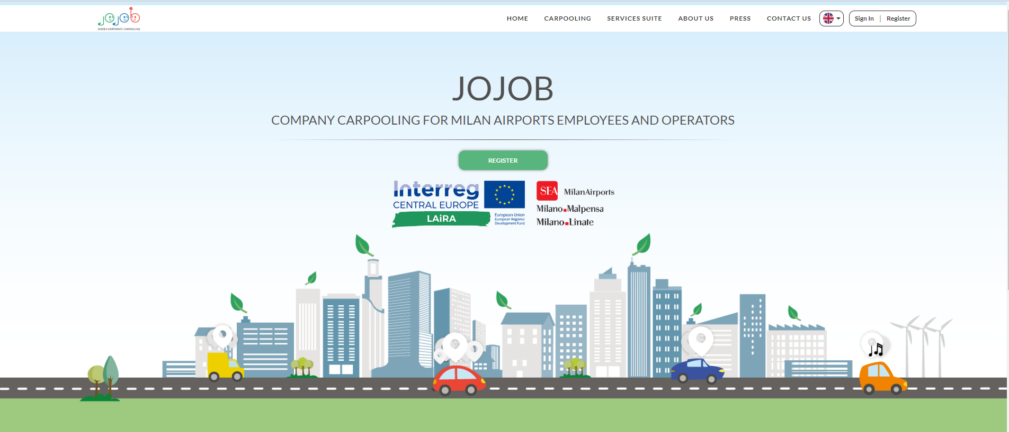
Figure 1. Jojob website landing page for Milan Airports in the LAirA project

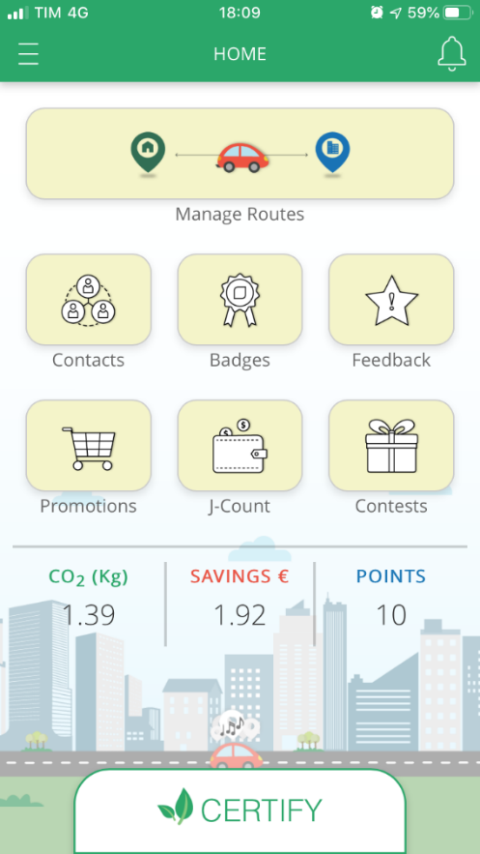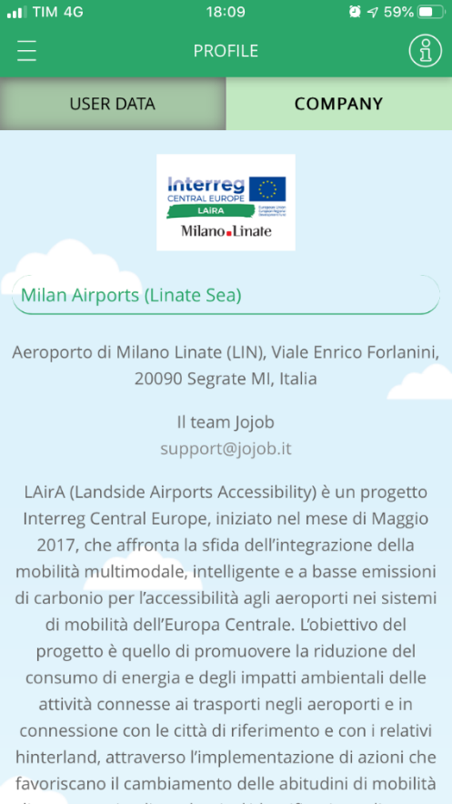
Figure 2. Jojob car-pooling mobile app with a description of the LAirA project

