Output fact sheet

Strategies and action plans

Version 2

Project index number and acronym | CE1352 S3HubsinCE
Output number and title | O.T3.3 Transnational Policy & Technology Blueprint for CERIS3 Excellence
Responsible partner (PP name and number) | PP8 TECOS & PP2 FB & PP4 IWU
Project website | https://www.interreg-central.eu/Content.Node/S3HubsinCE.html
Delivery date | 07 December 2021 (DT3.3.2)

Summary description of the strategy/action plan (developed and/or implemented), explaining its main objectives and transnational added value
The Transnational Policy & Technology Blueprint for CERIS3 Excellence adresses the challenges on how to promote Central European RIS3 Excellence by enhancing the Digital Innovation Hubs (DIHs) network. Therefore, the Blueprint answers one main objective which is to provide guidance on how to enhance the DIHs network. By containing evidence-based recommendations and insights on how to enhance the DIHs network towards excellent operation which can promote market and strategic-oriented development, delivering close-to-market and Research & Innovation Smart Specialisation Strategy benefits, the partners were able to forecast and think about future actions and cooperation. The Blueprint report answers the following question: “How can policy-makers and best-in-class organisations work together to evidence RIS3 implementation at the local, regional and national level”. This report was created using 10 Training & Mobility (T&M) Actions (1 per partners) aimed at strengthening linkages between DIHs, using methods such as study visits, common seminars etc., to build trust and understanding on how to appropriately support RIS3-aligned digital innovation; and 34 Transfer & Cooperation (T&C) Actions (min. 3/partners) aimed at showcasing how a connected network of DIHs can be used to actively promote activities which enable market-oriented benefits to organisations which are critical for smarter territorial specialisation. Thus, exchanges all across Europe were used to build and test a common model to promote transnational, stakeholder-oriented, policy-supporting digital transformation to inform long-term planning. Discussion to create and foster future cooperation were developed in this report (enhancing the learning environment, policymakers commitments, markets needs and relevant technologies by developing infrastructures, strategies, supporting DIHs operations and market activities).

NUTS region(s) concerned by the strategy/action plan (relevant NUTS level)
CUAS – AT21, Kärnten (NUTS 2)
FB – AT11, Burgenland (NUTS 2)
Bwcon – DE11, Stuttgart (NUTS 2)
Fraunhofer IWU – DED4, Chemnitz (NUTS 2)
Intellimech – ITC4, Lombardia (NUTS 2)
Ecipa – ITH3, Veneto (NUTS 2)
KPT – PL21, Malopolskie (NUTS 2)
TECOS – SI01, Vzhodna Slovenija (NUTS 2)
PBN – HU22, Nyugat-Dunántúl (NUTS 2)
Croatian Chamber of Economy - Varaždin- HR04, Kontinentalna Hrvatska (NUTS 2)

Expected impact and benefits of the strategy/action plan for the concerned territories and target groups
The Blueprint is a complete summary of all project partner activity results. It creates a strong overview which connects the needs analysis completed by Partners at the start of S3HubsinCE, to the tangible, evidence-based Digital Innovation Hub Pilot programme developed in the project, to the development of future-oriented next steps to sustain the model to promote Central European RIS3 Excellence. This document is first directed towards the Partner Consortium, who wants to learn how to promote an efficient connected network of Digital Innovation Hubs but also aimed to be spread to the stakeholders involved indirectly in the project. This document serves as a foundation for further reflections on the success of the project’s strategic vision and navigation crew’s specific objectives to bring value to the stakeholders critical to RIS3 implementation. Partners and stakeholder ecosystem gained new and committed cooperation partners (eg. Austrian CiSMAT institute & smart³ grew).

Sustainability of the developed and/or implemented strategy/action plan and its transferability to other territories and stakeholders
The last section of the Blueprint provides Discussions and Recommendations on how to use the results for future actions and therefore enhance those results. Insights on who needs to work together, on which topics and on how they need to further cooperates have been pulled out and disseminate to the partners and to the public for future actions to emerge. These results as they gather inputs from T&M and T&C Actions consider lots of different territories and therefore provides a broad panel of potential future actions for all territories in Europe. As it was presented during the final conference in Krakow and is now publicly available on the project website, every stakeholder related to the DIHs network can benefit from this Blueprint. One main lesson learned from this Blueprint is that implementing territorial and transnational actions (T&M and T&C) have greatly benefited the elaboration of recommendations.

References to relevant deliverables and web-links
If applicable, pictures or images to be provided as annex
This deliverable DT3.3.2: TRANSNATIONAL POLICY & TECHNOLOGY BLUEPRINT FOR CERIS3 EXCELLENCE can be found on the project website: https://www.interreg-central.eu/Content.Node/S3HubsinCE/D.T3.3.2-Technology-Blueprint.pdf. Moreover, this Blueprint was presented during the D.C.5.5 – S3HubsinCE Final Conference alongside RIS3 Investment Forum:
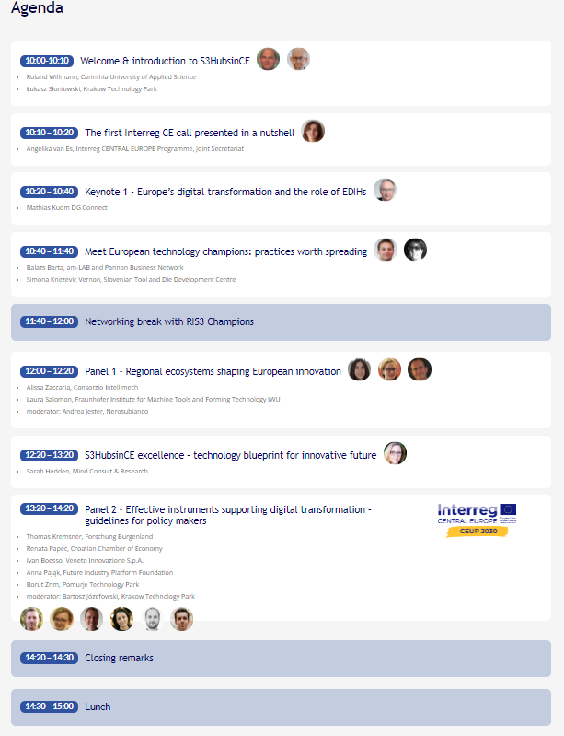
Figure 1 Agenda of the RIS3 Investment Forum (Source: S3HubsinCE, 2021) with evidence of presentation of the Blueprint (circled in red).

