Output fact sheet

Innovation networks

Version 2

Project index number and acronym | CE1352 S3HubsinCE
Output number and title | OT3.1 Foundation for Future Foresight (F3)
Responsible partner (PP name and number) | TECOS PP8 & IWU PP4 & HGK VZ PP10 & PBN & KPT
Project website | https://www.interreg-central.eu/Content.Node/S3HubsinCE.html
Delivery date | 26 April 2021 (DT3.1.2) & 03 January 2022 (DT3.2.2) & 28 January 2022 (DT3.2.3)

Summary description of the established innovation network explaining its structure, functions and transnational character
The Foundation for Future Foresight (F3) is a sustainable innovative network formed through mutual cooperation of multiple actors with an intention to better achieve goals. The F3 addresses the challenge of identifying and bringing together regionally significant & transnationally relevant RIS3 Champions, so as to promote the exploitation of knowledge & exchange across the wider territorial area. The F3 extends O.T1.1 – CERIS3 Navigation Crews, with the Constellation of CERIS3 Excellence, a connected network of DIHs and subsequently identified RIS3 Champions (SMES, LEs, RTD & BSOs) who characterize best-in-class representation of the different territories’ smart specialization strategy plus long term resilience planning to deliver ongoing services to these entities. In addition to the 10 DIHs and 10 connecting Navigation Crews, 51 RIS3 Champions were identified & engaged as part of the project’s work with this innovation network (41.2% SME, 22.5% RTO, 13.7% LE, 13.7% BSO, 2.0% Tech Transfer, and 2.0% DIH specific) and a group of interested participants (from the F3 Forums) complete the network structure. Champions were identified during PP/Navigation Crew exchange & investigation of regional needs & transnational opportunities & development of pilot actions (WP2); and then selected, presented & pitched in two meetings of the F3 Forums. The transnational added value of this process is to bring-to-light exceptional players across the territory, who promote strong RIS3 focus, and demonstrate/discuss in real-terms, how the Navigation Crews can provide ongoing support to these & other organisations critical for regional development. The network’s main activities are to promote specific knowledge exchange on key thematic topics (Navigation Crew topics), and raise awareness about the RIS3 Champions, and promote the success stories of how to work with these organisations to boost smart specialization strategies in different territories.

NUTS region(s) concerned by the innovation network (relevant NUTS level)
Partner NUTS2 Regions:
CUAS – AT21, Kärnten (NUTS 2)
FB – AT11, Burgenland (NUTS 2)
Bwcon – DE11, Stuttgart (NUTS 2)
Fraunhofer IWU – DED4, Chemnitz (NUTS 2)
Intellimech – ITC4, Lombardia (NUTS 2)
Ecipa – ITH3, Veneto (NUTS 2)
KPT – PL21, Malopolskie (NUTS 2)
TECOS – SI01, Vzhodna Slovenija (NUTS 2)
PBN – HU22, Nyugat-Dunántúl (NUTS 2)
Croatian Chamber of Economy – Varaždin- HR04, Kontinentalna Hrvatska (NUTS 2)

Other involved NUTS Regions/Territories
DE13, Freiburg (NUTS 2)
DE12, Karlsruhe (NUTS 2)
DE14, Tubingen (NUTS 2)
DE30, Berlin (NUTS 2)
DED2, Dresden (NUTS 2)
HU11, Budapest (NUTS 2)
HR05, Grad- Zagreb (NUTS 2)
SI04, Zahodna Slovenija (NUTS 2)
Portugal (NUTS 0)
Israel (NUTS 0)
Saudi Arabia (NUTS 0)
Greece (NUTS 0)
Switzerland (NUTS 0)
Belgium (NUTS 0)
Egypt (NUTS 0)
Spain (NUTS 0)
Brasil (NUTS 0)

Expected impact and benefits of the innovation network for the concerned territories and target groups
The innovation network (and events occurring within the network) is/are expected to raise awareness over best-in-class organisations who are critical to the success of RIS3 in numerous territories, and exchange success stories on how to best support these organisations & their eco-systems to expand the benefits and more effectively meet RIS3 targets. All participants benefit from the network. On the one hand, the DIHs, connected via the Navigation Crews learn about cross-territory successes and build understanding about how they can work together and independently to build greater RIS3 outcomes. On the other hand, the RIS3 Champions and regional eco-systems gain a transnational support structure which can be used to help expand/build on success stories and promote wide-spread access to knowledge across a number of territorial stakeholders. Policy makers, too, benefit from the innovation network, as they are invited to hear about these top regional actors and the needs/support infrastructure which is requested to unleash smart/competitive potential for a wider group of stakeholders.

Sustainability of the innovation network and its transferatbility to other territories and stakeholders
It has been determined that the innovation network will be sustained via the Navigation Crews which connect the DIH Eco-Systems. Through D.T3.2.3 the Partners have completed Resilience Planning to determine what next step formalization will occur to enable detailed, deep-dives on key topics of territorial importance – especially due to the shift of RIS3 to S4 (sustainable, smart specialization strategies) in parallel to the programming period of 2021 to 2027. For example, through next step initiatives, such as the planned SMART CIRCUIT, the partners will formalize strategic activity on Innovation in a Circular Economy and include other territories (CZ & SK + new regions). Additionally, steps to continue the network have already been established in CEUP 2030, with regards to a specific focus on Trend & Innovation Networks in Advanced Manufacturing, specifically in AI, Data, Automation & Robotics and Smart Materials and next step Flagships are being formalized across Horizon Europe and ERDF projects to finance ongoing network activities & include other territories. Future Foresight generated in the F3 Forums is critical to provide stakeholders a common vision and common baseline for working together. Key Lessons surrounding the total number of topics linking the network should be considered (better to have 3-5 thematic networks + mandatory all participation network to really enhance cross territorial cooperation models), this was especially challenging to overcome when no more physical meeting of the network was allowed due to COVID19 measures.

References to relevant deliverables and web-links
If applicable, pictures or images to be provided as annex
D.T3.1.1 – Guidance for Constellations of CERIS3 Excellence – RIS3 Champions
D.T3.1.2 – Constellations of CERIS3 Excellence -RIS3 Champion Network Atlas - https://www.interreg-central.eu/Content.Node/S3HubsinCE/D.T3.1.2-RIS-CHAMPIONS-NETWORK-ATLAS.pdf
D.C.4.3 – Constellations of RIS3 Excellence – CERIS3 Champion Network Infographic & E-Book - https://www.interreg-central.eu/Content.Node/S3HubsinCE/D.C.4.3.Consterallation-of-RIS3-Exellence-ebook-digital.pdf
D.T3.2.1 – Handbook on the Foundation for Future Foresight (F3) for CERIS3 Excellence
D.T3.2.2 – Foundation for Future Foresight (F3) Forums for CERIS3 Excellence
D.T3.2.3 – F3 for CERIS3 Excellence, Learning & Resilience Planning - https://www.interreg-central.eu/Content.Node/S3HubsinCE/D.T3.2.3-F3-for-Learning--Resilience-Planning.pdf
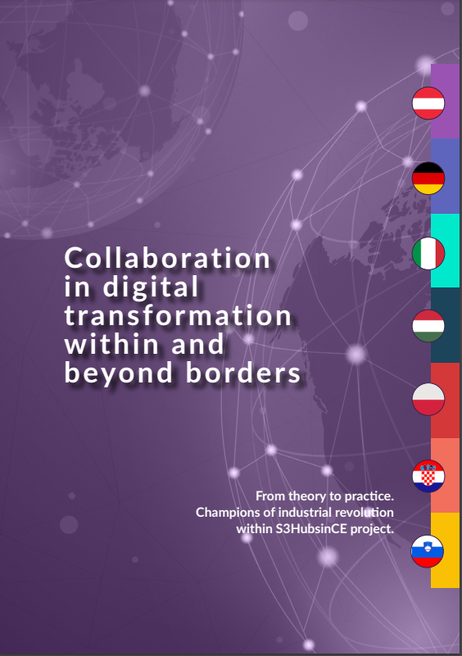
Figure 1 Front Cover of the RIS3 Champions Network Infographic & E-Book
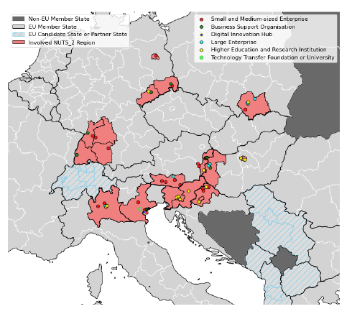
Figure 2 Geographical Distribution of RIS3 Champions

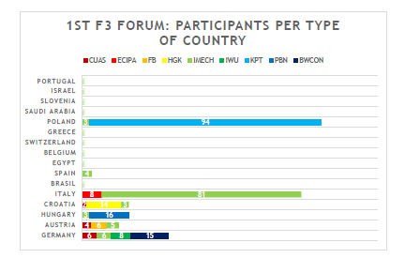
Figure 3 Participants Per Country at the 1st F3 Forum (Source: S3HubsinCE, 2021)
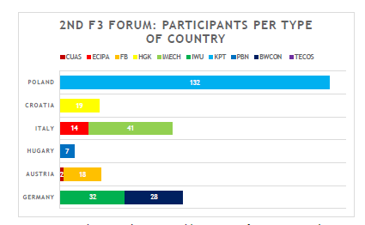
Figure 4 Participants by Country at the 2nd F3 Forum (Source: S3HubsinCE)

