REGISTRATION FORM & Booking of accommodation & LOGISTIC NOTES
for participation IN MID TERM CONFERENCE
(20./21.03.2019 in TISZAKÉCSKE, HUNGARY)
Please fill out this form and return to PP8 MTDWD Project Management Team -
E-mail: tiszaoffice@kotivizig.hu , keeping in cc : rainman@iu-info.de; Sabine.Scharfe@smul.sachsen.de

The meeting will be held in the Barack Hotel Thermal & SPA
Address: Rózsabarack tér 2, 6060 Tiszakécske, Hungary
Tel: +36 76 541 100 https://www.google.com/maps/place/Barack+Thermal+Hotel+%26+Spa/@46.9379591,20.121871,15z/data=!4m5!3m4!1s0x0:0xeae5541e2826c96a!8m2!3d46.9379591!4d20.121871

Name | Title:
 | Mr. Ms. | Surname:
 |  | First name:
Position/title
Department
Organization
Address
Zip code |  |  | City
Country
Telephone
Email
PARTICIPATING on the | Conference Part (20 March)  Partner Meeting (21 March)  Study Tour (21 March)
Travel information | If travel itinerary is not finalized, please inform on the travel arrangements at later date.
 | Arrival | Date: |  | Hour (approx.):
 | Departure | Date: |  | Hour (approx.):
Accommodation | BARACK Hotel Thermal & SPA – Tiszakécske 6060, Rózsabarack tér 2., Hungary  https://www.barackhotel.hu/en  Block reservations have been made, but each participant should make his/her own booking directly via the hotel to info@barackhotel.hu with the CODE of booking „RAINMAN” and keep in ‘Cc’ tiszaoffice@kotivizig.hu :

Transfers from airport / bus or railway-station Budapest / railway station Kecskemét to Tiszakécske | MTDWD PP8 will arrange the transfers to and from Budapest Liszt Ferenc Airport, Budapest Keleti Railway-station, Budapest Nyugati Railway-station, Kecskemét Railway-station.  The schedule will be shared after the closing of registrations.  Please include me on the list of transfer  from/to Budapest Liszt Ferenc airport to/from the Hotel  from/to Budapest Keleti Railway-station to/from the Hotel  from/to Budapest Nyugati Railway-station to/from the Hotel  from/to Kecskemét Railway-station to/from the Hotel
Dietary requirements: | Please indicate if you have any special requirements.  Omnivore Coeliac disease  Vegetarian Lactoz intolerance
Diet | The Organizer arranges:  March 19, 2019 Dinner  March 20, 2019 Lunch Dinner  March 21, 2019 Lunch Dinner

LOGISTIC NOTES
Tiszakécske

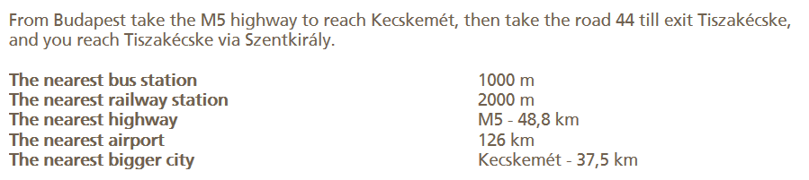
In case of need MTDWD will provide transfer from the airport and railway-stations of Budapest or/and Kecskemét from/to as well.
Please, indicate it in the registration form in the relevant part!

Meeting Venue & Accomodation:

BARACK Hotel Thermal & SPA
Tiszakécske 6060, Rózsabarack tér 2., Hungary

https://www.google.com/maps/place/Barack+Thermal+Hotel+%26+Spa/@46.9379591,20.121871,15z/data=!4m5!3m4!1s0x0:0xeae5541e2826c96a!8m2!3d46.9379591!4d20.121871

