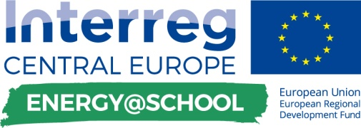

training of jeg’s about how to use application
- planning activities

Template for the  DELIVERABLE D.T.4.4.2. | 01. 2019

Edited by PP6 UNIBO



This document shows the activities planned in schools, by each partner country of the E @ S Project, for the training of Junior Energy Guardians in the use of the E @ S application, which will be used during the gamification phase, for the collection data and monitoring.

PP9 – Germany

PLANNING MAIN ACTIVITIES OF TRAINING SUPPLIED BY SEG’s TO JEG’s
GUIDED EXERCISES | The simulation of the use of the application guided by SEG's, could certainly be one of the most interesting and useful training initiatives for the young JEG's
In case, that the video tutorials aren´t enough training for the JEGs, an employee of the city of Stuttgart will give guided exercises for the use of the application in areas, where problems occurred.

VIDEO TUTORIAL | Tutorials will help students to be more efficient and Independent at work
The video tutorials will forwarded to SEGs, who show them to JEGs.

