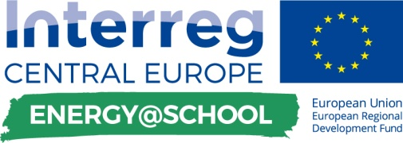

training of jeg’s about how to use application
- planning activities

Template for the  DELIVERABLE D.T.4.4.2. | 01 2019

Edited by PP6 UNIBO

This document shows the activities planned in schools, by each partner country of the E @ S Project, for the training of Junior Energy Guardians in the use of the E @ S application, which will be used during the gamification phase, for the collection data and monitoring.

PP8 – Hungary - ÚJSZILVÁS

PLANNING MAIN ACTIVITIES OF TRAINING SUPPLIED BY SEG’s TO JEG’s
THEORETICAL LESSONS WITH TECHNICAL INSIGHTS | This phase may require the need for short and simple lectures on some basic notions, aimed at a greater understanding of the type of data that must be specified in the application, both during the training and gaming phase.
the children quickly understood and learned the terms of the abbreviations used in the application, as some of the abbreviations used in the school were well known from their school studies, so the treatment of the surface was not a problem for them.

GUIDED EXERCISES | The simulation of the use of the application guided by SEG's, could certainly be one of the most interesting and useful training initiatives for the young JEG's
After completing the daily work routines presented by the SEGs, the children were able to see the processes more quickly and to understand the topic of the aggregation of the data entered and the meaning of the results obtained from them. After completing the task, the children were able to complete the process of performing a daily task independently.

VIDEO TUTORIAL | Tutorials will help students to be more efficient and Independent at work
All four educational materials were welcomed by children. Videos provide you with quick and serious help in the rapid development of your daily routine. The most positive thing about video materials is that they are easily accessible and can be viewed at any time, and not too long, which does not draw the children 's concentration on one task.

OTHERS ACTIVITIES
Yes, it made the overall approach and understanding of the presentation, the task and the program prepared for education smoother. The presentation presented some of the phenomena with the children that led to this project.
What is the greenhouse effect? How does it develop?
What do we call fossil fuels?
What is Renewable Energy? Etc.

