

Tools and Simulator Game Upgrated to be used by School egs into the Community

Edited by PP6 - UNIBO

N. DELIVERABLE D.T. 4.5.2.

Energy Manual for school jointly developed by junior and senior

Version 01

03.2019

Edited by PP6 - UNIBO

N. DELIVERABLE D.T. 4.5.2.

Tools and Simulator Game Upgrated to be used by School egs into the Community

Version 01

03.2019

CONTENTS

 | Page
- INTRODUCTION  - ENVIRONMENTAL EDUCATION, THE IMPORTANCE OF TRAINING THE CITIZENS OF TOMORROW | 4  4
3. D.T.4.5.1. SUMMARY | 5
- D.T.4.5.2. SUMMARY  - HOME EDUCATIONAL EXERCISE | 5  6

- INTRODUCTION
Toll and simulator game up gratuated was implemented and adapted to models outside the schools and the JEGs are available now to became guardians in everyday life outside of school; in fact, this document introduces the first sustainable steps of an Energy Guardian, even outside the school, for example in a domestic context.

- ENVIRONMENTAL EDUCATION, THE IMPORTANCE OF TRAINING THE CITIZENS OF TOMORROW
School has always been a place where tomorrow's citizens are trained and guided in the knowledge of their surroundings. In this sense, today more and more environmental education takes on a key role within the classrooms. Teaching young people respect for the environment, the distinction between renewable and non-renewable energies, the causes that cause environmental pollution and other similar issues, becomes an indispensable resource to be able to train aware citizens able to act tomorrow for the good of the community.
The importance of introducing environmental education into school environments is also linked to the fact that this discipline, by being able to explain complex scientific concepts in a language more accessible to everyone, is able to trigger changes in young people and in society in general behaviour towards the surrounding world. This translates into greater respect for the environment in which we live, with a consequent reduction in unnecessary waste and a high sensitivity to the use of renewable energy rather than non-renewable. At the same time, environmental education plays an important role in society and in schools as it promotes the active participation of individuals when it comes to making decisions about the environment and the community, thus helping to provide ideas and effective solutions to resolve ecosystem problems.

- D.T.4.5.1. SUMMARY
- Guide to the JEG's of the school, to profiling, necessary to play at the E @ S Competition, once the sensors have been installed;
- Inventory phase (CHECK UP) of equipment instruments present in the various classrooms of the school building, to define the theoretical basic consumption;
- Selection of the classrooms to be monitored, generally the more energy-intensive ones,
- Development of the Energy Action Plan, as action strategies to reduce electrical and thermal waste;
- Download of the APP;
- Registration of classrooms and sensors, to create your own credentials;
- Login and start of consumption monitoring, for the final Gamification phase.

- D.T.4.5.2. SUMMARY
- Start of a new teaching phase, where teachers will have to guide the Jeg’s to self-reading and understanding the household bills;
- Guide the JEGs to the identification of the 4 data requested in the first level of the Home Edition App! (annual electrical consumption (kwh), annual gas consumption (m3), size of your home (m2), Energy source 100% renewable (yes or not).
- By entering the data, previously identified in the bills, you get the domestic emission class to which you belong, as a final result;
- The optional module of HOME CHECK UP will also be suggested below, to be completed as a home training exercise, in order to carry out the home inventory, similar to what was done previously in one's own school, to be able to understand where they are concentrated greater consumption and hypothesizing intervention strategies to learn how to manage them and thus limit waste;
- The optional training exercise can be completed with the development of an energy action plan for domestic action, in order to identify the strategies necessary to realize the savings.

- HOME EDUCATIONAL EXERCISE
LINK TO LOGIN IN THE APP:
https://energyatschool.finmatica.it/#/login/
The JEGs of each school will be able to take advantage of the HOME EDUCATIONAL home extension included in the E @ S App, as a further exercise to spread the well-understood good practices thanks to the school experience. In the "HOME" section, below the "TUTORIAL" heading, you can find and test the HOME EDUCATIONAL exercise.

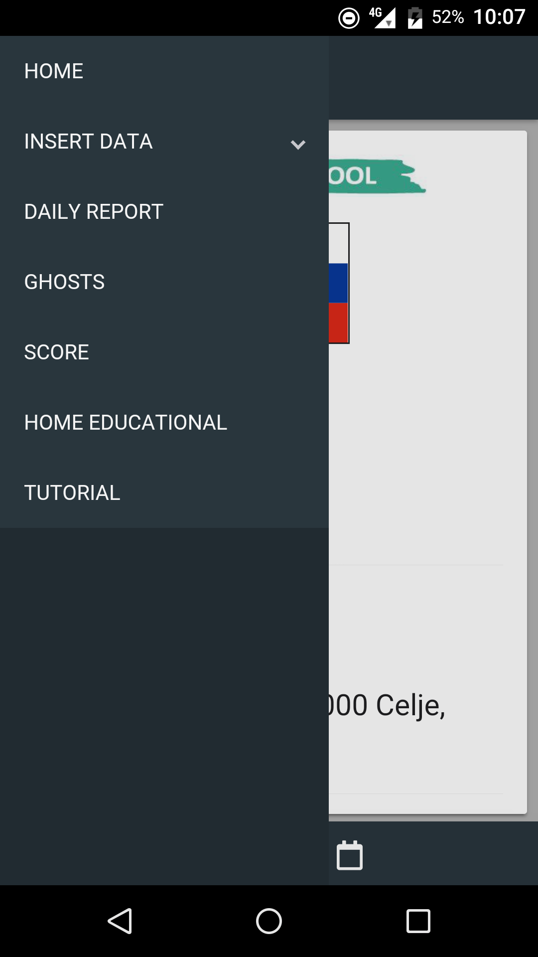
SCREEN 1: Screen of access (HOME PAGE) where to find the HOME EDUCATIONAL exercise.

Entering the HOME EDUCATIONAL extension, you will be asked for 4 simple data, to be found on your last electrical and gas bills.
- annual electrical consumption (kwh),
- annual gas consumption (m3),
- size of your home (m2),
- if your Energy source is 100% renewable (yes or not).
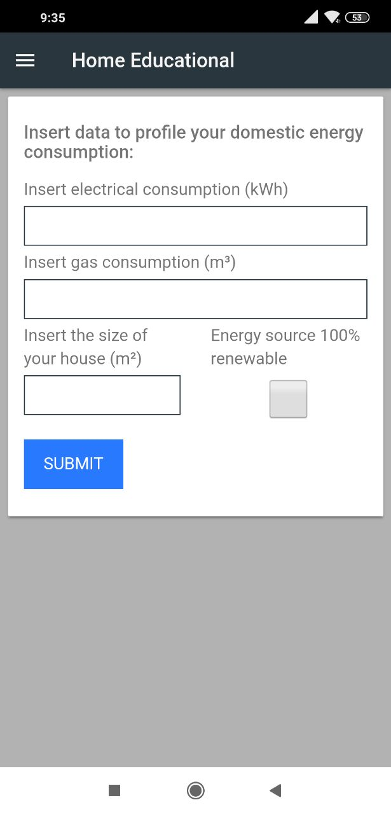
SCREEN 2: Screen of first page of HOME EDUCATIONAL exercise.

Entering the requested data, your emissive class will be calculated.
The emission class of a house is the amount of carbon dioxide that is emitted annually from your home and is measured as kg of carbon dioxide per square meter of living space (kgco2/mq). The amount of carbon dioxide depends on your domestic consumption of electricity and heating. The higher classes such as A and B are those in which carbon dioxide emissions per square meter are lower. In general, a higher class corresponds to a house that consumes more and therefore also represents an index of the efficiency with which you consume energy inside your home.

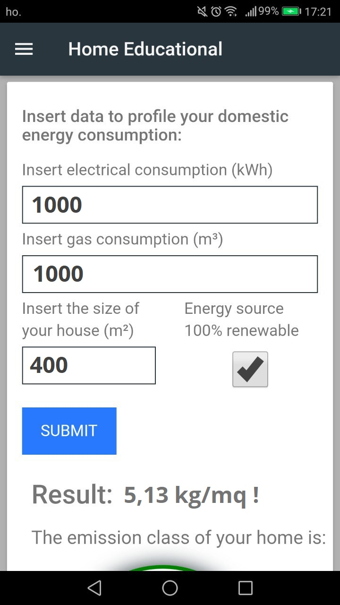
SCREEN 3: Screen of final result, the issuing class of belonging.

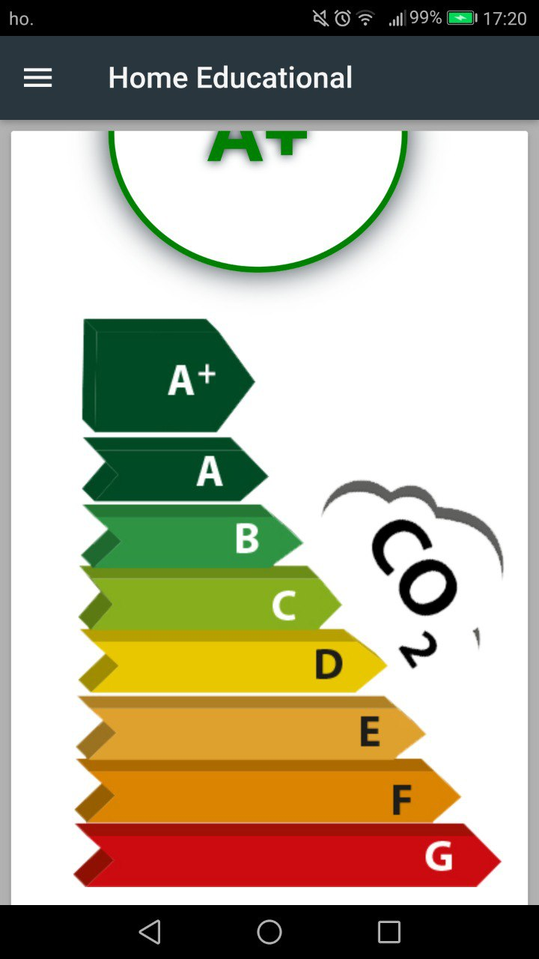
SCREEN 4: Screen of final result, the issuing class of belonging.

