

DETAILS ABOUT SELECTION OF JUNIOR ENERGY GUARDIAN’S TEAM

Version 01

31.10.2017
EDITED BY PP6 UNIBO

D.T4.1.2. DETAIL ABOUT SELECTION OF JUNIOR ENERGY GUARDIAN’S TEAM

Version 01

31.10.2017

Edited by PP6 UNIBO

CONTENT

 | Page
Abstract | 5
Average statistical analysis of the teams | 5
List of JEG’s team for all the schools involved in the E @ S Project | 7

1. ABSTRACT

This document contains information about the boys selected for the JEG'S TEAM of all the schools involved in the Energy@school Project. Specifically, data relating to:

Name of school

Classroom

Age of students

Number of students

Name of teacher/s or reference persons for classroom

For the respect of the privacy of the young individualities involved, it was considered appropriate to omit their names.

2. AVERAGE STATISTICAL ANALYSIS OF THE TEAM

Out of a total of 47 participating schools, the distribution, in terms of age and number of components for each selected team, appears to be quite heterogeneous.

The PP1 PILOT (ITALY) is the one with the smallest number of teams but reaches the largest number of components, with 26 Guardians per team; while the PILOT PP8 (HUNGARY) is the partner that presents the team with the smallest number of participants, exactly the youngest to participate are 7 years old and form one of the PP10 Austrian team. The age of the JEG’ s ranges from the minimum of seven years to the maximum of 17. The age range found in the formation of the various teams ranges from 11 to 13 years.

Table 1 shows all the schools and respective countries involved in the E @ S project and the number of Junior Energy Guardians belonging to the different age ranges chosen by the schools at the time of the selection of the boys for the training of the Junior Energy Team. The table shows also the total JEG’s selected for each school, the total of JEG’s for each age range, and the corresponding percentage value calculated for the total number of boys involved in all participating European countries.

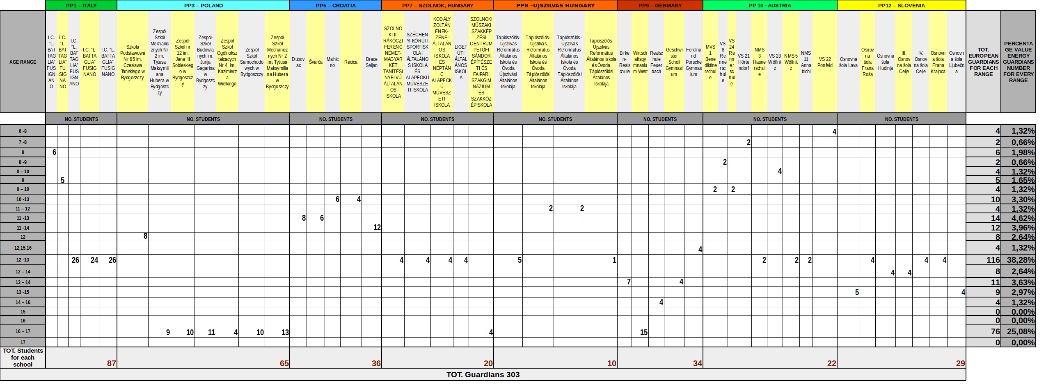
TABLE 1: Number of Junior Energy Guardians belonging to the different age ranges chosen by the schools.

Figure 1 shows the percentage value, previously calculated and reported in the table, of the total incidence of JEG’s for each age range. Selected age ranges are highlighted each with a different color and, of course, with a different area, which will vary depending on the number of guys belonging to the specific range.

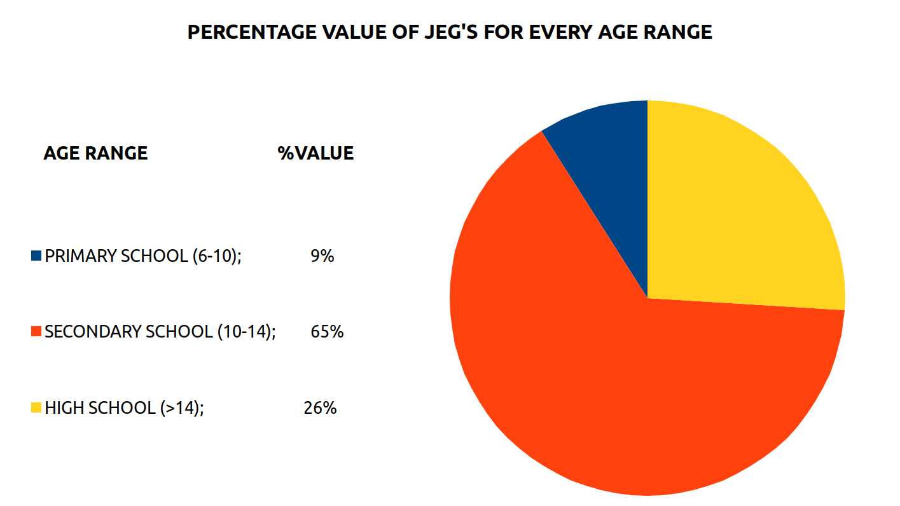
FIGURE 1: Percentage value of JEG’s for every range

3. LIST OF JEG’S TEAM FOR ALL THE SCHOOL INVOLVED IN THE E @ S Project

PP 1 Unione dei Comuni della Bassa Romagna (ITALY)
Nome della scuola | I.C. “L. BATTAGLIA” FUSIGNANO
Classe | 3^D scuola Primaria
Età degli studenti | 8 anni
Numero degli studenti | 6 Junior Energy Guardian:
Nome dell’insegnante o della persona di riferimento della classe | GOLFARI MARIA CATERINA  CONTOLI BARBARA

Nome della scuola | I.C.”L. BATTAGLIA”
Classe | 4^ B scuola primaria
Età degli studenti | 9 anni
Numero degli studenti | 5 Junior Energy Guardian:
Nome dell’insegnante o della persona di riferimento della classe | GAGLIARDI MARIA ANTONIETTA

Nome della scuola | I.C. “L.Battaglia” FusIgnano
Classe | 2°A
Età degli studenti | 12 - 13 anni
Numero degli studenti | 26
Nome dell’insegnante o della persona di riferimento della classe | Rubboli Annalisa  Zalambani Danilo

Nome della scuola | I.C.”L.Battaglia” Fusignano
Classe | 2°B
Età degli studenti | 12 – 13 anni
Numero degli studenti | 24
Nome dell’insegnante o della persona di riferimento della classe | Milanesi Fabia  Regazzi Anna

Nome della scuola | I.C.”L.Battaglia” Fusignano
Classe | 2°C
Età degli studenti | 12 – 13 anni
Numero degli studenti | 26
Nome dell’insegnante o della persona di riferimento della classe | Fusari Gabriella  Mura Cynthia Carolina

PP3 City of Bydgoszcz (POLAND)
Name of school | Szkoła Podstawowa Nr 65 im. Czesława Tańskiego w Bydgoszczy
Classroom… | several classes
Age of students | 12
Number of students | 8
Name of teacher/s or reference persons for classroom | Maciej Iwiński  Michał Butowt  Krzysztof Szmidt

Name of school | Zespół Szkół Mechanicznych Nr 2 im. Tytusa Maksymiliana Hubera w Bydgoszczy
Classroom… | several classes
Age of students | 16-17
Number of students | 9
Name of teacher/s or reference persons for classroom | Magdalena Putz  Marzena Czechumska

Name of school | Zespół Szkół nr 12 im. Jana III Sobieskiego w Bydgoszczy
Classroom… | several classes
Age of students | 16-17
Number of students | 10
Name of teacher/s or reference persons for classroom | Kinga Trzosek  Joanna Słowiow  Andrzej Rutz

Name of school | Zespół Szkół Budowlanych im. Jurija Gagarina w Bydgoszczy
Classroom… | several classes
Age of students | 17
Number of students | 11
Name of teacher/s or reference persons for classroom | Wojciech Mrozik-Gliszczyński  Damian Kin

Name of school | Zespół Szkół Ogólnokształcących Nr 4 im. Kazimierza Wielkiego
Classroom… | several classes
Age of students | 17
Number of students | Up to now 4, but will be more
Name of teacher/s or reference persons for classroom | Krzysztof Chabasiński  Sławomir Wandycz

Name of school | Zespół Szkół Samochodowych w Bydgoszczy
Classroom… | several classes
Age of students | 16-17
Number of students | 10
Name of teacher/s or reference persons for classroom | Łukasz Zgórski  Tomasz Kasprowic

Name of school | Zespół Szkół Mechanicznych Nr 2 im. Tytusa Maksymiliana Hubera w Bydgoszczy
Classroom… | several classes
Age of students | 16-17
Number of students | 13
Name of teacher/s or reference persons for classroom | Beata Dolata  Beata Jastrzemska  Ewa Bratz  Zbigniew Marolewski

PP 5 City of Karlovac (CROATIA)
Name of school | Dubovac
Classroom… | 5 and 6 grade
Age of students | 11 – 13 years
Number of students | 8
Name of teacher/s or reference persons for classroom | Maja Navijalić

Name of school | Švarča
Classroom… | 5 and 6 grade
Age of students | 11 – 13 years
Number of students | 6
Name of teacher/s or reference persons for classroom | Snježana Protulipac

Name of school | Mahicno
Classroom… | 4, 5 and 6 grade
Age of students | 10 – 13 years
Number of students | 6
Name of teacher/s or reference persons for classroom | Gorana Simic - Vinski

Name of school | Recica
Classroom… | 4, 5 and 6 grade
Age of students | 10 – 13 years
Number of students | 4
Name of teacher/s or reference persons for classroom | Blazenka Mravunac

Name of school | Brace Seljan
Classroom… | 5, 6 and 7 grade
Age of students | 11 – 14 years
Number of students | 12
Name of teacher/s or reference persons for classroom | Maja NavijalićJanjiš

PP 7 SZOLNOK (HUNGARY)
Name of school | SZOLNOKI II. RÁKÓCZI FERENC NÉMET-MAGYAR KÉT TANÍTÉSI NYELVŰ ÁLTALÁNOS ISKOLA
Classroom… | 7B
Age of students | 12-13 Years
Number of students | 4JEG
Name of teacher/s or reference persons for classroom | Mrs. Henrietta Kátai Kolozsvári

Name of school Iskola neve | SZÉCHENYI KÖRÚTI SPORTISKOLAI ÁLTALÁNOS ISKOLA ÉS ALAPFOKÚ MŰVÉSZETI ISKOLA
Classroom… | 7
Age of students | 12-13 Years
Number of students | JEG:4
Name of teacher/s or reference persons for classroom | Mrs. Andrea Pesti Kovács

Name of school | KODÁLY ZOLTÁN ÉNEK-ZENEI ÁLTALÁNOS ISKOLA ÉS NÉPTÁNC ALAPFOKÚ MŰVÉSZETI ISKOLA
Classroom… | 7
Age of students | 12-13 Years
Number of students | JEG:4
Name of teacher/s or reference persons for classroom | Mrs. Márta Náhóczki

Name of school | LIGET ÚTI ÁLTALÁNOS ISKOLA
Classroom… | 7B
Age of students | 12-13 Years
Number of students | 4JEG
Name of teacher/s or reference persons for classroom | Mr. István Fejes

Name of school | SZOLNOKI MŰSZAKI SZAKKÉPZÉSI CENTRUM PETŐFI SÁNDOR ÉPÍTÉSZETI ÉS FAIPARI SZAKGIMNÁZIUM ÉS SZAKKÖZÉPISKOLA
Classroom… | 11B and 11C
Age of students | 16-17 Years
Number of students | 4JEG
Name of teacher/s or reference persons for classroom | Mrs. Tamara Veronika Angi

PP 8 Újszilvás (HUNGARY)
Name of school | Tápiószőlős-Újszilvás Református Általános Iskola és Óvoda Újszilvási Általános Iskolája  ÚJSZILVÁS
Classe | 7.
Age of students | 12-13
Number of students | 5 Junior Energy Guardian:
Name of teacher/s or reference persons for classroom | Dömök Szilvia  Molnárné Szabó Szilvia

Name of school | Tápiószőlős-Újszilvás Református Általános Iskola és Óvoda Tápiószőlősi Általános Iskolája  TÁPIÓSZŐLŐS
Classe | 6. a
Age of students | 11-12
Number of students | 2 Junior Energy Guardian:
Name of teacher/s or reference persons for classroom | Tanács Edit  Mikusné Maczó Rozália

Name of school | Tápiószőlős-Újszilvás Református Általános Iskola és Óvoda Tápiószőlősi Általános Iskolája  TÁPIÓSZŐLŐS
Classe | 6. b
Age of students | 11-12
Number of students | 2 Junior Energy Guardian:
Name of teacher/s or reference persons for classroom | Tanács Edit  Mikusné Maczó Rozália

Name of school | Tápiószőlős-Újszilvás Református Általános Iskola és Óvoda Tápiószőlősi Általános Iskolája  TÁPIÓSZŐLŐS
Classe | 7.
Age of students | 12-13
Number of students | 1 Junior Energy Guardian
Name of teacher/s or reference persons for classroom | Tanács Edit  Mikusné Maczó Rozália

PP 9 LHS Stuttgart (GERMANY)
Name of school | Birken-Realschule
Classes | 8a, 8b, 8c
Age of students | 13-14
Number of students | 7
Name of teacher/s or reference persons for classroom | Christine Graß

Name of school | Wirtschaftsgymnasium West
Classes | JG1.1, JG 1.4
Age of students | 16-17
Number of students | 15
Name of teacher/s or reference persons for classroom | Diethard Schmid

Name of school | Realschule Feuerbach
Classes | 9a, 10a
Age of students | 14-16
Number of students | 4
Name of teacher/s or reference persons for classroom | Ruben Kratky

Name of school | Geschwister Scholl Gymnasium
Classes | 7a, 9c
Age of students | 13-14
Number of students | 4
Name of teacher/s or reference persons for classroom | Michael Bodmer

Name of school | Ferdinand Porsche Gymnasium
Classes | 7, 9, 10, 11
Age of students | 12, 15, 16
Number of students | 4
Name of teacher/s or reference persons for classroom | Dieter Bareis

PP10 Landeshauptstadt Klagenfurt am Wörthersee (AUSTRIA)
Name der Schule | \MVS 1 Benediktinerschule
Klasse | 4.b
Alter der Schüler | 9 – 10 Jahre
Zahl der Schüler | 2 Junior Energy Guardians
Name des/r LeherIn und/oder des/r SchulwartIn | Angelika Reitermayer,  Katja Steiner  Sascha Moser

Name der Schule | VS 8 Rennerschule
Klasse | 3 a
Alter der Schüler | 8 – 9 Jahre
Zahl der Schüler | 2 Junior Energy Guardians
Name des/r LeherIn und/oder des/r SchulwartIn | Mlinar Christina,  Bernhard Stocker

Name der Schule | VS 24 Rennerschule
Klasse | 4
Alter der Schüler | 9 – 10
Zahl der Schüler | 2 Junior Energy Guardians
Name des/r LeherIn und/oder des/r SchulwartIn | Poppernitsch Katharina  Bernhard Stocker

Name der Schule | VS 21 Hörtendorf
Klasse | 2
Alter der Schüler | 7 – 8 Jahre
Zahl der Schüler | 2 Junior Energy Guardians
Name des/r LeherIn und/oder des/r SchulwartIn | Höffernig Ulrike  Kulterer Claudia  Irene Müller

Name der Schule | NMS 3 Hasnerschule
Klasse | 3 b
Alter der Schüler | 12 – 13 Jahre
Zahl der Schüler | 2 Junior Energy Guardians
Name des/r LeherIn und/oder des/r SchulwartIn | Sabine Magerle  Patrik Striednig  Manfred Uitz

Name der Schule | VS 23 Wölfnitz
Klasse | 3 a und 4 a
Alter der Schüler | 8 – 10 Jahre
Zahl der Schüler | 4 Junior Energy Guardians
Name des/r LeherIn und/oder des/r SchulwartIn | Karin Haberl  Anja Danesh-Pajuh-Wildhaber  Florian Minarik

Name der Schule | NMS 5 Wölfnitz
Klasse | 3
Alter der Schüler | 12 – 13 Jahre
Zahl der Schüler | 2 Junior Energy Guardians
Name des/r LeherIn und/oder des/r SchulwartIn | Stefan Lobnig  Michaela Brückler  Florian Minarik

Name der Schule | NMS 11 Annabichl
Klasse | 3
Alter der Schüler | 12 – 13 Jahre
Zahl der Schüler | 2 Junior Energy Guardians
Name des/r LeherIn und/oder des/r SchulwartIn | Ursula Weyrer  Josef Cech  Edelhart Proprentner

Name der Schule | VS 22 Ponfeld
Klasse | 1 und 2
Alter der Schüler | 6 – 8 Jahre
Zahl der Schüler | 4 Junior Energy Guardians
Name des/r LeherIn und/oder des/r SchulwartIn | Astrid Erlacher  Maria-Luise Hübner  Isabella Mölcnik

PP 12 in PP4 (SLOVENIA)

Name of school | Osnovna šola Lava
Classroom | 8
Age of students | 13 - 15
Number of students | 5
Name of teacher/s or reference persons for classroom | Benjamin Karner, učitelj  Polona Hrovat, učiteljica

Name of school | Osnovna šola Frana Roša
Classroom | 7
Age of students | 12 - 13
Number of students | 4
Name of teacher/s or reference persons for classroom | Franjo Roškar, učitelj  Stanislav Verdev, hišnik

Name of school | Osnovna šola Hudinja
Classroom | 7 in 8
Age of students | 12 - 14
Number of students | 4
Name of teacher/s or reference persons for classroom | Uroš Kalar, učitelj  Simon Antlej, hišnik

Name of school | III. Osnovna šola Celje
Classroom | 7 in 8
Age of students | 12 - 14
Number of students | 4
Name of teacher/s or reference persons for classroom | Katarina Kurnik, učiteljica  Andreja Cvelfer, učiteljica

Name of school | IV. Osnovna šola Celje
Classroom | 7
Age of students | 12 - 13
Number of students | 4
Name of teacher/s or reference persons for classroom | Marja Poteko, učiteljica  Helena Čuvan, učiteljica

Name of school | Osnovna šola Frana Krajnca
Classroom | 7
Age of students | 12 - 13
Number of students | 4
Name of teacher/s or reference persons for classroom | Sabina Hriberšek, učiteljica  Mateja Štor, učiteljica

Name of school | Osnovna šola Ljubečna
Classroom | 8 in 9
Age of students | 13 - 15
Number of students | 4
Name of teacher/s or reference persons for classroom | Mojca Trobentar, učiteljica  Roman Žnidarec, hišnik

