

D.T 2.2.2 "SOFTWARE ALGORITHM FOR ASSESSMENT AND EVALUATION OF ENERGY-SAVING PERFORMANCES"

Version 01

03.2018

Edited by PP6 UNIBO

D.T. 2.2.2 “SOFTWARE ALGORITHM FOR ASSESSMENT AND EVALUATION OF ENERGY-SAVING PERFORMANCES”

Version 01

03.2018

Edited by PP6 UNIBO

INDEX

1. DATA ANALYSIS SPECIFICATIONS – Inventory phase (Training Exercise) | 4
2. METHODS FOR COLLECTING AND ANALYZING ELECTRICAL CONSUMPTION DATA  3. SIGNALING ALGORITHMS OF AN EVENTUAL ELECTRIC GHOST | 4  6
4. MANAGEMENT OF A GHOST BY THE JEGs | 7
5. SOME EXAMPLES OF ENERGETIC GHOST AND THEIR MANAGEMENT  6. METHODS FOR COLLECTING AND ANALYZING TEMPERATURE AND CONSUMPTION DATA  7. ALGORITHMS FOR REPORTING A POSSIBLE THERMAL GHOST  8. MANAGEMENT OF A GHOST BY THE JEGs  9. SOME EXAMPLES OF THERMAL GHOST AND THEIR MANAGEMENT | 8  10  12  13  14

DATA ANALYSIS SPECIFICATIONS

Inventory phase (TRAINING EXERCISE)
In the inventory phase the specifications of each single room will be collected, in particular:
● presence of devices (which absorb energy) and of what type (power, w*h, and other characteristics)
● Estimated use of each device (number of hours), to calculate the theoretical consumption of the room
● Association between the room and the electrical sensor from which it is covered

The JEGs followed by the SEGs will produce a theoretical consumption calculation for each room, based on the number of devices and their estimated use.

At the end of the inventory phase, in addition to the theoretical consumption data, a map of the building must be provided with the rooms being analyzed and the position of the electrical sensors.
- Methods for collecting and analyzing electrical consumption data
For each smart meter of electric consumption will be taken 3 measures:
1. morning
2. noon
3. afternoon
By measurement we mean the counter of W*h (watthour), incremental counter that measures the energy consumption.
Calculating the delta between the current measure and the previous measure will mean the average consumption between the 2 measures.
Night / baseline consumption is calculated with the delta between the last measure in the afternoon and the first in the morning.
You will then get 3 values:
1. Real morning consumption (per sensor)
2. Real afternoon consumption (per sensor)
3. Night / night real consumption (per sensor)
Consumption will refer to the sum of consumption of all the rooms covered by the smart meter.
In the inventory phase, the SEGs will have produced consumption estimates for each single room, based on the devices present and their estimate of use, producing the following data
1. Estimated consumption hours
2. Estimated baseline consumption

You then get to have the following data, which will be used for the analysis of consumption and the related reports of problems:
● Calculated theoretical consumption by JEGs for each room (use and baseline)
● The theoretical calculated consumption by the JEGs for all the rooms covered by the smart meter, calculated as the sum of the theoretical consumption of each room.
● Real consumption morning, afternoon, night / baseline for each smart meter, based on data sent by JEGs.
● Average of real consumption on the basis of the monitoring period (for the calculation of the daily deviations from the theoretical profile as the sum of the individual contributions of each room).
● Identifying the most energy-hung rooms compared to all the rooms that have a low average consumption or shared spaces

For the calculation of the means and the tuning of the algorithms a 2-month phase is necessary in which there will be data collection but no ghost signaling.

The presence sensor can be a useful tool for the JEG to make efficiency and to prevent access devices without people.

Below is an example graph of the values ​​obtainable on a sensor:

- Signaling algorithms of an eventual electric ghost
It is not possible with the data collected to have a precise indication of which room has high or different consumption. So, the indication of the "ghost" is based on the increase in average consumption read by the smart meter in the three time slots. It is up to the JEGs to understand the room that generated the problem, based on presence data, particular activities or energy-saving devices that have been turned on more than necessary.
A GHOST, is to be understood as a purely abstract concept, which indicates the presence of an energy WASTE, or an energy SAVING; a ghost appears whenever there is a situation that can lose points (with a waste) or to earn points (with savings); everything is in the hands of JEGs and their ability to hunt all those devices or not good habits or unusual situations, which being sources of waste or energy savings, will have to be resolved and eliminated!
We could consider, for simplicity, also the following symbols, replacing the Energetic GHOST;
ENERGY WASTE ENERGY SAVING


The conditions for which a ghost is considered are the following:
If you have a monthly consumption history:
● Energy Ghost: Current daily consumption, which deviates from the real monthly average based on the monitored spread
● Night Ghost: Night / baseline consumption that deviates from the monthly average according to the monitored spread
If the consumption history does not exist:
• Energy Ghost: Current daily consumption, which deviates from the daily average of the previous day / s. At the end of each month, the constructed monthly average profile will automatically be saved as a monthly history. At the beginning of the new month, the software will reset for the construction of the new middle profile of the following month.
• Night Ghost: Current nighttime consumption, which deviates from the daily night average of the previous day / s. At the end of each month, the constructed monthly average profile will automatically be saved as a monthly history. At the beginning of the new month, the software will reset for the construction of the new middle profile of the following month

- Management of a ghost by the JEGs
The app shows the anomaly generated by an increase and / or a reduction in consumption compared to the average of the monitored time band, we are talking of a ghost.

Depending on whether the ghost is an Energy ghost or a Night ghost, the signal will be different.
The JEG will take care of the investigation, trying to understand what was the room that generated greater consumption or behavior (lights in the hallway, projection of a movie) that increased electricity consumption.
Each waste (consumption higher than the average value), identified by daily time band, constitutes the loss of a point while, in the same way, any accrued savings will constitute the purchase of a point.

- Some examples of Energetic Ghost and their management:
Example 1:
On Monday morning, in the school several photocopies are made in the teachers' room to prepare a lesson.
Reference in chart A, RED LINE, Score -1, because it is higher than the average estimated in previous periods.
The JEG will have the indication of an Energy Ghost in the areas of its sensor, but has no evidence of why, will report the Ghost and must succeed in the enterprise of the capture and recovery of the identified waste, always referring to the comparison with the school staff, who as in this example, it could have performed very expensive operations in terms of energy without the JEGs knowing about it.
Example 2:
Monday afternoon, for example from 15 to 17, in class 1B, a movie is shown with the use of a particularly energivorous (not LED) projector.
Reference in the chart A, BLUE LINE, score -1, because it is higher than the average estimated on the previous days, if without consumption history, or on the basis of the monthly history, if in possession of an accumulation of consumption data of the months or years previous.
The JEG that manages the area covered by the electric sensor will have the indication of an Energy Ghost in the rooms covered by the sensor of its competence.
Analyzing the events of the same day will note that a projector was used to view a movie, will evaluate, if necessary, any possibility of intervention and modification, both for the methods and frequency of use and for the quality of the device itself.
GRAPHIC A
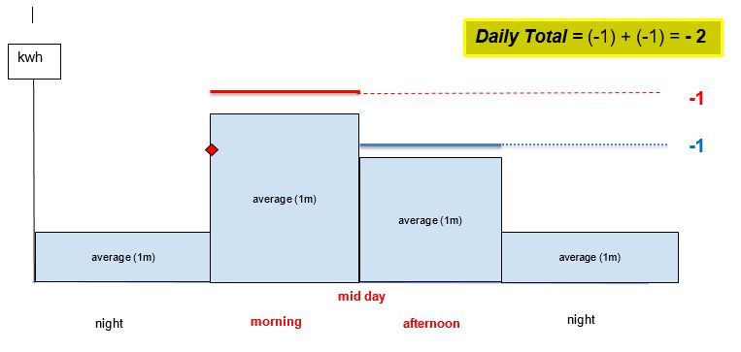

Example 3:
One morning the JEG finds a Night Ghost report. Surveys show that in a classroom exposed to the North it was very cold and the teacher asked to be able to use an electric heater to heat, but that heater remained on all night from the previous afternoon.
Reference in graph B, GREEN LINE, score -1, because it is still higher than the average established on the basis of previous consumption.
The JEG will be able to close the report by indicating the Ghost as "captured" and inviting the teacher to turn off the appliances when not in use.
Example 4:
In the same morning, during the computer lesson, the boys decided to work in groups, using less computers, to raise the shutters, making the most of natural light, not having to use the projector, thus being able to turn off the halogen lamps in the class.
Reference in chart B, ORANGE LINE, score +1, because below the established average, are making efficiency.
The JEG in charge of managing the ghosts of that day, will have to evaluate, even in the case of efficiency, how to improve even more that savings, and carefully analyze for example, if it is of interest to replace the old lamps with LED lights and advise all classes to organize, in computer rooms, in working groups.
Example 5:
In the afternoon, the boys of the 1 A, go to the gym for the lesson of physical education, but forget, in a hurry, the lights on.
Reference in graph B, VIOLET LINE, score -1, because it is higher than established average.
The JEGs in charge of the presence monitoring, will report the energy ghost capturing it immediately, thanks to its inspection. This is why presence monitoring can be very useful in ghost hunting!
GRAPHIC B
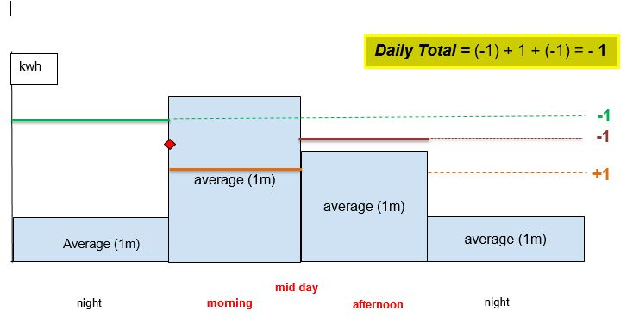

6. Methods for collecting and analyzing temperature and consumption data
The thermal consumption sensor will most likely be single for the whole building.
3 measurements will be read from the sensor:
1. Morning
2. Mid day
3. Afternoon
By measurement we mean the meter of Kw*h or m3 (thermal kilowatt hours or cubic meters of gas depending on the type of sensor), so that the real consumption will be deduced from the delta between two values.
You will then get 3 values:
1. Real morning consumption (per sensor)
2. Real afternoon consumption (per sensor)
3. Night / night real consumption (per sensor) The consumption will refer to the sum of consumption of all the rooms covered by the sensor, or of the entire building if the sensor will be connected to the heating of the entire building. For each room, on the other hand, the presence and temperature data will be collected with the same frequency of the electricity consumption data, in particular:
1. presence (morning, noon, afternoon)
2. temperature (morning, noon, afternoon)
The following parameters will also be considered to determine the presence of situations not optimized for thermal consumption:
1. European thresholds of well-being in a room, which indicate the ideal temperature between 18 and 22 degrees
2. outdoor temperature (retrieved via public webservice) A two-month data collection period is foreseen, which will be used to determine the average consumption on a daily and monthly basis.

Below is an example graph for the analysis of temperatures:

t1, t2, t3 = temperatures detected by the JEGs. (1: MORNING, 2: MID DAY, 3: AFTERNOON)

Consumption analysis will instead be based on calculated averages, real consumption and external temperature:

- Algorithms for reporting a possible thermal ghost
The conditions for which a thermal ghost is considered to be managed by the JEGs will be:
- Current consumption that deviates from the real monthly average does not correspond to a lowering of the outside temperature (high consume ghost)
- Room temperature above 22 ° C (warm ghost)
- Room temperature below 16 degrees (frozen ghost)

The conditions for the SEG will be
- Temperature of a room outside the range of European well-being thresholds (T> 22 ° C or T <18 ° C) in the presence of people
- No sensor data collection

It is not possible, however, with the data collected on the mc of gas, to have a precise indication of which room has high or different consumption. So the indication of the "ghost" is based on the increase in average consumption read by the smart meter in the three time slots. It is up to the JEGs to understand the room that generated the problem, based on temperature and presence data.

The conditions for which a ghost is considered are the following:
If you have a monthly consumption history:
- Energy Ghost (mc gas and / or ° C): Current daily consumption, which deviates from the real monthly average based on the spread monitored
If the consumption history does not exist:
- Energy Ghost (mc gas and / or ° C): Current daily consumption, which deviates from the daily average of the previous day / s. At the end of each month, the constructed monthly average profile will automatically be saved as a monthly history. At the beginning of the new month, the software will reset for the construction of the new middle profile of the following month.

8. Management of a ghost by the JEGs
The app reports the presence of an anomalous consumption compared to the real monthly average and shows the temperatures detected on that day for the rooms monitored and for the outside.
In case of high consume, a generic ghost is shown, the JEG signals the consumption anomaly to the SEG and will manage together the identified waste, analyzing all the possible determinants of that day; for example, if a high-grade ghost ghost is often reported. The JEG evaluates with the classmates and the SEG the level of comfort of the school and discusses how to reduce energy consumption by reducing the temperatures in the classrooms without reducing comfort.
If the ghost is a warm ghost type, the JEG can evaluate together with the SEG whether to carry out corrective actions such as acting on the convectors if present or on the radiator valves; for example, two ghosts are reported, a warm ghost in class 1B and a frozen ghost in class 3A. Class 1B is aimed at SOUTH while 3A is NORTH. Together with the SEG there are considerations on how the arrangement of the classes with respect to the sun changes the temperature and how the radiators should be regulated accordingly, if possible. (For example, by means of thermostatic valves).
If the ghost is of the frozen ghost type, in addition to corrective actions on the convectors the JEG can signal the problem to the SEG for a possible action on the isolation of the room; for example, a frozen ghost is always reported in the chemistry lab. However, the laboratory is only used a few hours a week, so it is not necessary to heat it even when not in use, thus reducing energy consumption.
Each ghost, identified by daily time slot, constitutes the loss of a point while, in the same way, any accrued savings will constitute the purchase of a point if it has not neglected the state of well-being.

- Some examples of thermal Ghost and their management
Example 1:
To make it efficient, the school decides to lower the ° C of the established internal night temperature and also reduce the night time ignition of the radiators, since there are no people inside, programming the ignition three hours before the start of the morning lessons, so as to have an adequate index of well-being at the entrance of the boys to school.
Furthermore, during the afternoon, it is decided to switch off the radiators three hours before the actual closure of the school structure, letting the temperature and the mc of gas required for the production of heat decrease progressively, this will allow a good saving, maintaining an excellent index of well-being, if you pay attention to keep doors and windows tightly closed during the last activities.
Graphic reference C, score equal to +1 (in the night phase for the reduction of mc of gas), +1 (in the morning phase, for the temperature reduction detected thanks to the first monitoring of JEGs, T1 <18 ° C), + 1 (survey of the temperature T3 <18 ° C in the afternoon) and +1 (for the reduction of the mc of gas required for the production of heat).
The scores relating to the shares previously described in Example 1 will be counted only once, if the action is defined as permanent, this will allow automatic updating of average consumption profiles established on the basis of historical data accumulated or monitored by the previous day.
GRAPHIC C
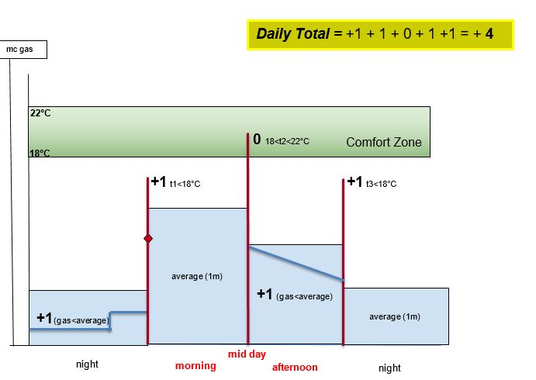
Example 2:
One morning, class 2C, goes to the gym for the time of physical education, forgetting the open windows and the open door, thus generating a strong current and heat dissipation; this drastically reduces the internal temperature of the class, leading to a greater consumption of mc of gas to produce heat and reach the temperature of ° C established for that school time.
Graphic reference D, score -1 for the anomaly detected (for the increase of mc of gas not linked to a rise in temperature, but to a drastic decrease), -1 (for temperature T2 <16 ° C, established as a minimum for a minimum level of well-being index).
Furthermore, in the afternoon of the same day, the 2E class is invited to the conference room for a conference. Forget the lights, the projector and the PCs on, this will cause the temperature established as the maximum threshold of the well-being index to be exceeded, t3> 22 ° C.
The JEG responsible for monitoring presence, reports the anomaly signaling a waste.
Graphic reference D, score -1 (for temperature T3> 22 ° C) and -1 (for the forgetfulness of the devices left on in the absence of people).
GRAPHIC D
