
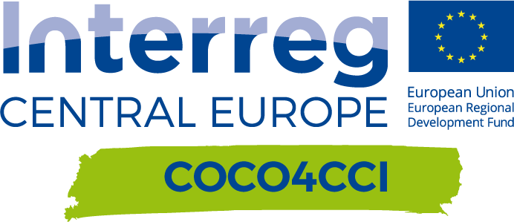
Match-Making via open innovation

Author(s):
REGION | Version 1  09 2021
Contributor(s):

Match-Making via open Innovation
Date | AVM challenge pitch | CCI solution (idea) pitch | Location | Participants
 |  |  |  | AVM | CCI
 | x
TOTAL

Project relevance:
These events are based on the concept for the three dimensions workshops (D.T2.3.2). The piloting is described in D.T3.2.1.

Event Title
DESCRIPTION
FEEDBACK
PHOTOS

Event Title
DESCRIPTION
FEEDBACK
PHOTOS

Event Title
DESCRIPTION
FEEDBACK
PHOTOS

FOLLOW-UP

OUTPUT

