
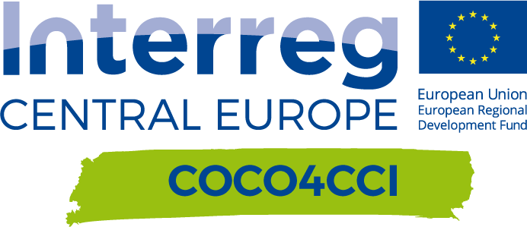
ChallenGe+shop (Challenge pitch)

Author(s): Denisa Rášová (SBA)
Slovakia | Version 1  03/2021
Contributor(s): Ladislava Juhászová (CIKE)

CHALLENGE+SHIP
Date: 24.02.2021
Location: Online (Zoom)

Project relevance:
This event is partially based on the concept for workshops for match-making (D.T2.4.2). The piloting is described in D.T3.3.2 “Match-making via open innovation, Design Thinking workshops”.

Participants:
// Number of participants: 23
// Participant structure:
8 AVM representatives (6 companies in total)
11 CCI representatives
4 project team and facilitators
Target groups: both CCI and AVM

Event
DESCRIPTION
The main aim of the Challenge+shop event was to present AVM challenges in front of CCI representatives. The online event started with welcome and encouraging words by our project manager at SBA, Andrej Špánik, who is a serial entrepreneur in the field of engineering and experienced in cooperating with CCIs. After the welcome session, a video was presented to better understand main functionalities, features and instructions on how to navigate on the COCO4CCI matchmaking platform. Afterward 6 AVM companies introduced their challenges in the topic of circular economy in front of CCI audience. Each company was given 5 min for a brief presentation and 10 min were reserved for Q&A session. At the end, next steps in the project process were presented by CIKE. The event was officially kicked-off at 9:15 AM and was concluded at 12:00 AM.

LESSONS LEARNT
The concept of the event proved to be successful, participants saw an added value in listening to other challenges proposed by AVM companies. As for the next activities, we will schedule follow-up events in the afternoon, since CCI representatives are mainly busy during the day and cannot reserve time earlier. Based on the feedback from CCIs, we identified these bottlenecks:
1/ In some cases, a 3rd party (intermediary company, waste processor, recycler or expert) is missing in the process,
2/ companies did not share a forecasted budget for a project. CCIs need to be aware of the project budget or at least a budget range to have an idea of how ambitious the proposed solutions should be.

FEEDBACK
AVM companies weren’t asked to fill in a feedback form, but according to the follow-up communication with some AVM representatives, they were satisfied with the high quality of the event, professional coordination and a fruitful discussion.
A feedback form was distributed among CCI representatives, only 3 replies were collected. The overall quality of the event was rated high (rating: 4 out of 5) and CCI representatives considered the event to be relevant for their business activities (rating: 4 out of 5). According to the feedback form, two out of tree creatives plan to participate in the design of an idea / solution, one respondent is hesitating. 1 out of 3 respondents declared that not all challenges were clearly identified. Further observations and lessons learned are elaborated in the above section.
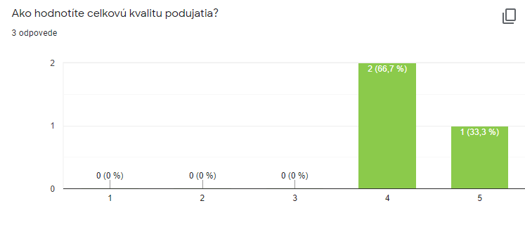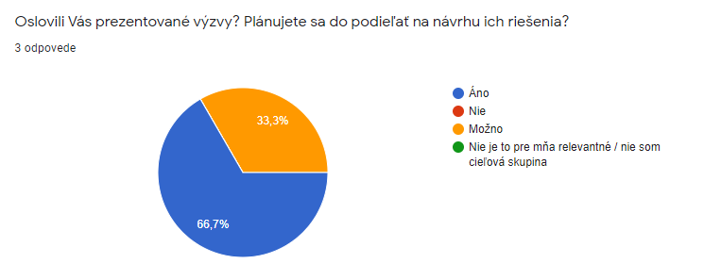
Selected results from the feedback form (in Slovak)

FOLLOW-UP
Further communication and networking among participants were initiated via the COCO4CCI online matchmaking platform. Based on collected feedback and lessons learned our COCO4CCI tandem came with updated follow-up piloting activities:

1/ CCIs were provided with presentation templates for an “Idea+Shop” event (Idea Pitch),
2/ “Idea+Shop” - during the event CCIs will present their draft ideas in front of AVMs, who will select a winning idea,
3/ “Idea Development Shop” - Winning idea will receive 500 euro grant to elaborate the idea in a more detailed proposition,
4/ AVM companies uncover their budget to be allocated for the idea development and enter into an agreement with CCIs,
5/ Successful match was born and tandem partners provide tailor-made support to matched couples.

OUTPUT
Video testimonial:
This event was recorded and uploaded on our COCO4CCI platform to be available for everyone registered in the COCO4CCI online matchmaking platform. The recording is not freely available.
Another video introducing the COCO4CCI online matchmaking platform was recorded and uploaded on the platform. The video is not freely available.
Online material:
N/A

PHOTOS

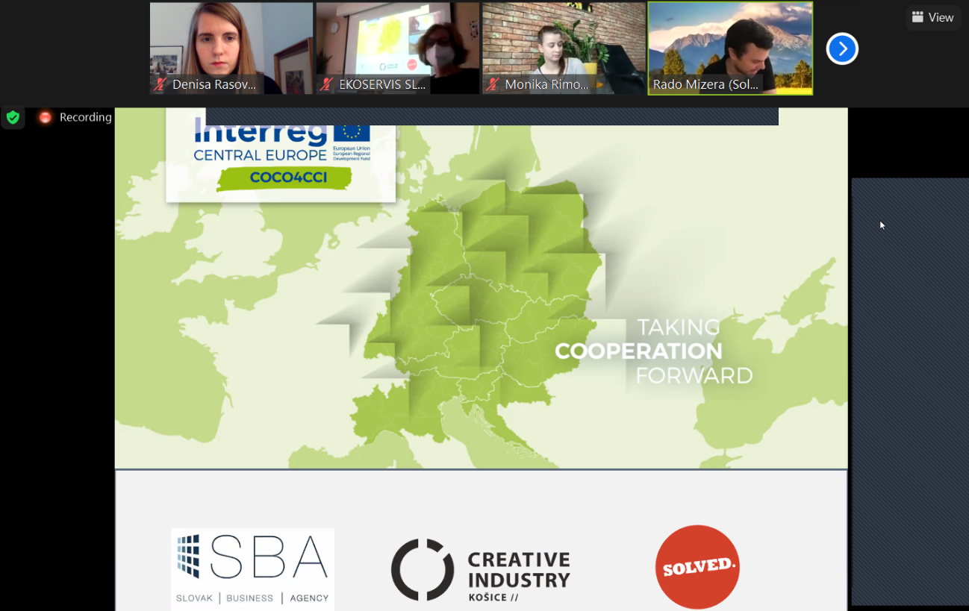

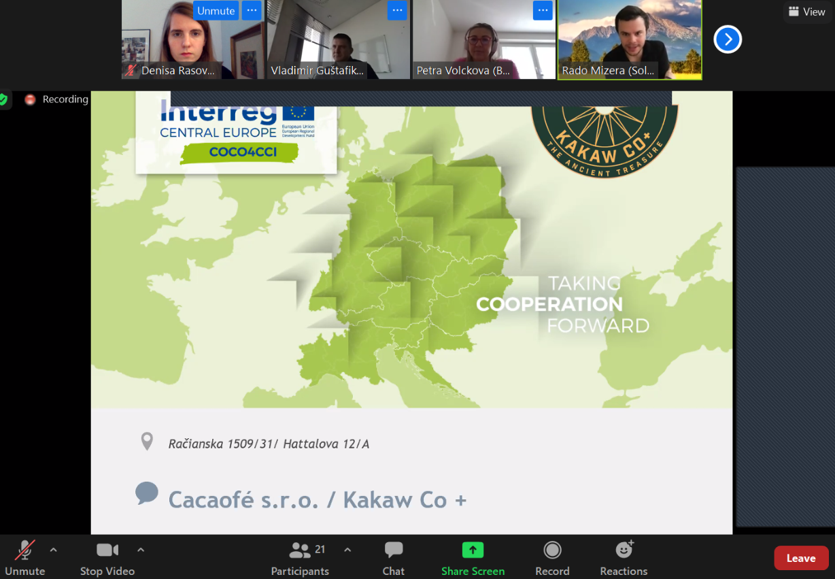
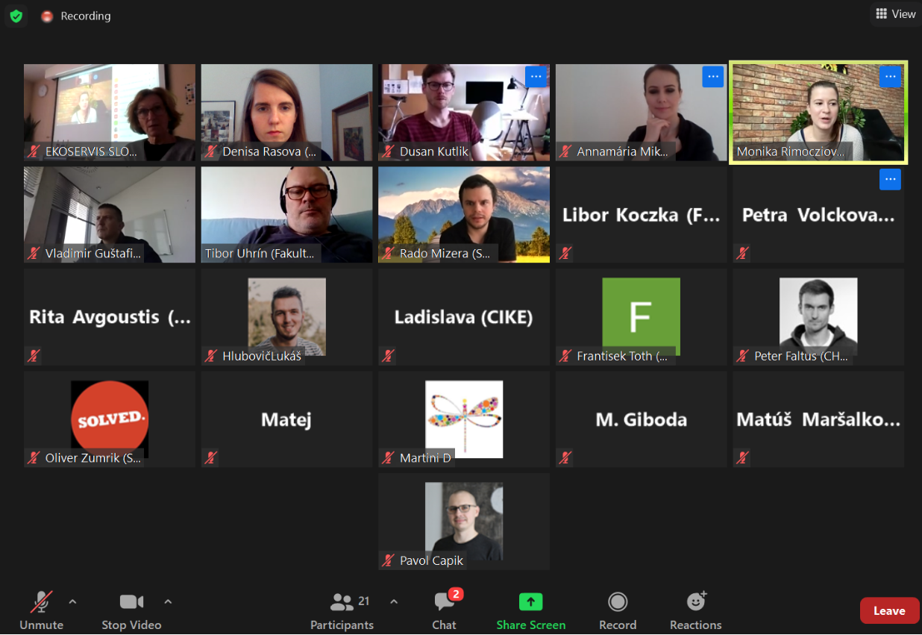

ANNEX 1: Agenda

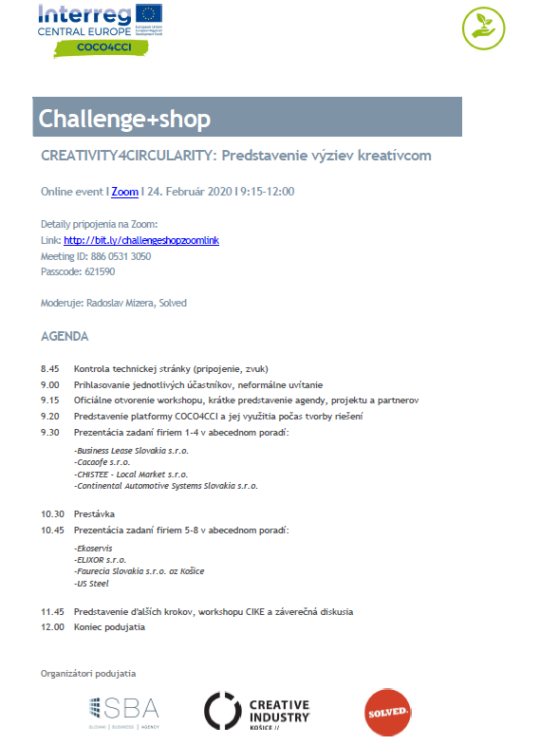

ANNEX 2: List of participants

