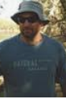
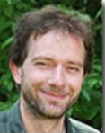
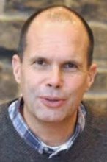
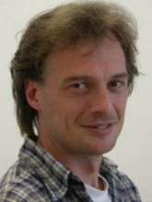
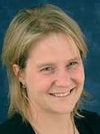
This 3Lynx training scheme for veterinarians, other stake-holder and interest groups will provide information on methods and techniques of forensic examination, necropsy and analysis, case reports; genetic sampling; anaesthesia, anaesthesia monitoring. A short introduction on darting with blowpipe, dart projector and jabstick will support the presentations.

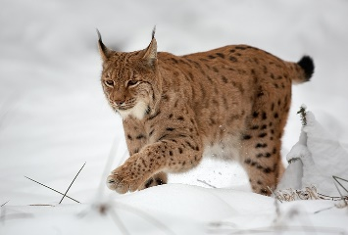

Webinar: 3Lynx Training Workshop
Agenda
10⁰⁰ – 11¹⁵: Basics of Forensic Investigations (Dr. med. vet. Christoph Beiglböck)
11¹⁵ – 11³⁰: Break
11³⁰ – 13⁰⁰: Wildlife forensic analysis
- Genetic Sampling – which questions can be addressed?
(Dr. med. vet. Pamela Burger)
- From sampling to lab processing (Steven Smith PhD)
- Forensic case reports: Lynx and Wildcat (Dr. Felix Knauer)
13⁰⁰ – 14⁰⁰ : Lunch break
14⁰⁰ – 14³⁰ : Anaesthesia
(Univ.-Prof. Dr.med.vet. Chris Walzer, Dipl. ECZM)
14³⁰ – 15⁰⁰ : Practical Insights (Darting, Dart Projectors, Blowpipe, Jabstick)
15⁰⁰ - 16⁰⁰ : Q & A

