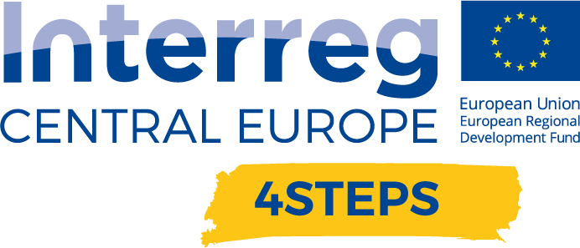
D.C. 5.1 Local focus groups events year 1

D.C. 4.2 Report – Local focus groups events year 1 – Partner CNA Emilia Romagna | Version 1  05 2020

- Name of the event, implementing date and place

NAME OF THE EVENT | DATE | PLACE
Opportunities for the companies: European calls, incentives for development and innovation | 19/3/2020 | Meeting in video conference
Business and sustainability: from theory to practice | 25/3/2020 | Meeting in video conference

- Number and types of participants/target groups
NAME OF THE EVENT | NUMBER OF PARTICIPANTS | TYPES OF PARTICIPANTS
Opportunities for the companies: European calls, incentives for development and innovation | 70 | SMEs
Business and sustainability: from theory to practice | 15 | SMEs

- Topics tackled and links to deliverables, outputs
1) Opportunities for the companies: European calls, incentives for development and innovation (March 19, 2020)
This workshop originated from the request of the companies of Reggio Emilia to deepen the interest and willingness to invest in new technologies and research and innovation projects to start new product, process and design solutions. The focus of the meeting was to analyze the main tools to finance the development of SMEs, starting from the European incentives, research and development and digitalization of production processes, within Industry 4.0.
At the end of the seminar, some companies requested information regarding funding to develop and start I4.0 projects.

2) Business and sustainability: from theory to practice (March 25, 2020)
The focus of this meeting was to analyze two concepts of development and differentiation opportunities such as "digitization" and "sustainability".
During the webinar, practical examples were given of how it is possible to combine "sustainability" and "business" in an effective and virtuous way, and how you can change your work to make it more sustainable.
This meeting, which caught the interest of the participants and initiated a fruitful exchange and discussion, was an opportunity to discuss topics, such as:

- sustainable technologies,
- opportunities for digitization in the area of sustainability,
- impact of the "policies" on sustainability,
- activation energy of sustainable supply chains.

The webinar was an opportunity to arouse interest and encourage the request of companies to start digitalization and sustainability paths.

- Expected effects and follow up
The Emilia Romagna region is a land of great excellence, with a business network of innovative and advanced companies, which have been able, over the years, to generate a supply chain capable of guaranteeing high quality production, through a dynamic and innovative ecosystem.
The SMEs of the Emilia Romagna region confirmed a widespread interest in the issues related to Industry 4.0 and a generalized willingness to consider investments in digital technologies, aware that this new industrial revolution will be one of the main strategic elements for the competitiveness of companies in the next years.
The two workshops organized garnered a lot of interest from companies, which acknowledged the importance of deepening the themes of Industry 4.0, as an opportunity to build a real business strategy. The aim of the workshops was twofold: "to sensitize" the entrepreneurs on the opportunities offered by Industry 4.0 and the 9 main enabling technologies, and to exploit the presence of some best practices to enhance the opportunities offered by the digital transformation on business development.
Following the four workshops, expressions of interest were collected from companies to participate in projects and to continue organizing seminars focused on Industry 4.0; in particular, on the topic of digitization, a further in-depth analysis was carried out, involving companies of the digital sector.

- Annexes: e.g. agenda of the event, pictures, media coverage web- links etc
NAME OF THE EVENT | LINK
Opportunities for the companies: European calls, incentives for development and innovation | https://www.interreg-central.eu/Content.Node/4STEPS/Workshop-Opportunities-for-the-companies.html
Business and sustainability: from theory to practice | https://www.interreg-central.eu/Content.Node/4STEPS/Workshop-Business-and-sustainability-from-theory-to-practic.html

