Digital Innovation Hub development composed by 3 boards with specific tasks

Deliverable D.T2.3.2  Digital Innovation Hub development_PBN | Final VERSION  02/2022

Project Number | CE1492
Project Name | Towards the application of Industry 4.0 in SMEs
Project Acronym | 4STEPS
Work package | WPT2 - From catalogue to action: local implementation of an intervention plan
Activity | Activity 2.3 - Digital Innovation Hub development
Deliverable | Deliverable D.T2.3.2 Digital innovation Hub development
WP responsible partner | DEX Innovation Centre
Dissemination Level | Public
Date of Preparation | - Template in word: 01.2022 prepared by DEX IC  - Final version: prepared by PBN on 15th February 2022
This document must be referred to as | DIH development, composed by 3 Boards with specific tasks_ PBN
Author | Template: prepared by DEX IC  Content: prepared by PBN
Contributors | PBN

Table of contents

1. Structure of DIH 3
1.1. Strategic Board 3
1.2. Scientific Board 5
1.3. Stakeholder’s Board 7
2. Main services of the DIH 7

- Structure of DIH
Digital Innovation Hubs (DIHs) are one-stop-shops that help companies to become more competitive with regard to their business/production processes, products or services using digital technologies. They are based upon technology infrastructure and provide access to the latest knowledge, expertise and technology to support their customers with piloting, testing and experimenting with digital innovations. DIHs also provide business and financing support to implement these innovations, if needed across the value chain.

DIH’s, facilitated in framework of 4Steps project are composed of 3 boards with specific tasks: 1) Strategic Board, 2) Scientific Board and 3) Stakeholder’s Board.

  - Strategic Board
Strategic board is focused on DIH’s governance. The board's key roles include strategic direction, oversight, policy setting, and fund-raising.

Regarding am-LAB (PBN’s) DIH, the following members belong to the strategic board:

- Municipality of Szombathely Local Public Authority
- University of Pécs (Health Science Institute) Higher Education and Research
- Technical University of Óbuda Higher Education and Research
- Eötvös Loránd University Higher Education and Research
- Chamber of Commerce of Vas County Business Support Organisation
- Scientific Association for Mechanical Engineering Business Support Organisation
- Institute for Transport Sciences Business Support Organisation
- Pannon Business Network Business Support Organisation

Main competencies of the Board Members:

Municipality of Szombathely

They are leading the city of Szombathely, as a local public authority, as a policy stakeholder.

University of Pécs

The Faculty of Health Sciences was established as a part of the Medical University of Pécs by the Minister of Health and Social Welfare in 1989 in order to offer courses for health care specialists leading up to the BSc degree. Today, after the integration process leading to the University of Pécs, the Faculty of Health Sciences is an independent organizational unit among the ten faculties of the University. Graduates of the Faculty of Health Sciences have a level of competence in their own field that is fully compatible with EU standards. They are fully capable to work as competent team members in areas of health care provision and social care systems. In the EU, there are seven automatically acknowledged special fields. They have been providing technical support mainly in connection with the newest developments at our DIH- the smart senior room.

Technical University of Óbuda

Research, development and innovation are a distinguished part of the university, which creates a well-balanced unity with the education. Research, development and innovation is implemented in high-standard, internationally-known basic researches, European and national research projects, as well as industrial developments and innovation.

Eötvös Loránd University

ELTE offers the widest educational portfolio in Hungary. It is the largest scientific establishment in the country. According to statistics (2016) ELTE is the most popular university in Hungary. Research activities at the eight faculties of Eötvös Loránd University are exceptionally diverse, covering nearly all scientific fields. The Center for Innovation manages the university’s tasks for organization of research. It supports the preparing of the development of research strategies. It attends ELTE’s tasks relating to innovation, cooperation with businesses and technology transfer is responsible for facilitating the exploitation of the research results produced by the University by acting as a bridge between the University and industry.

Chamber of Commerce of Vas County
The goal of the chamber is to create a service-minded, entrepreneur-friendly chamber with their new services, which will be the center of the county's economic life, a place that acts as a forum. They aim to play a leading role in the region in realizing a business economic environment whose members can prosper and compete effectively domestically and in the global market.

Scientific Association for Mechanical Engineering (GTE)
Their mission is to bring together professionals, companies and organizations working in mechanical engineering industry and related fields, to develop their professional skills and support their activities. Furthermore, serving the national and international interests of domestic industry, professional and expert activities, establishing and maintaining industrial cooperation, and international representation. The main platforms, where GTE is present as member or representative, are:
-Production Technology of the Future – exclusive domestic representation (ManuFuture)
- International Academy of Mechanical Engineering Technologists (CIRP)
-European Association of Agricultural Engineers (EurAgEng)
-International Association of Automotive Companies (FISITA)
-International Council for Aeronautical Sciences (ICAS)
-Industry 4.0 National Technology Platform – Founding Member (Industry 4.0)

Institute for Transport Sciences (KTI)
The mission of KTI is to create an increasingly evolving, safe and competitive environment in Hungary, taking into account the aspects of sustainable development - in the interests of a liveable environment.
The scope of KTI's activities covers the whole of transport, for instance it also covers the development of passenger transport, freight transport and infrastructure; and for rail, road, waterborne and air transport through horizontal elements such as transport safety, environmental protection, transport energy use and the use of smart technologies.
KTI is able to provide the options you need to make the right decision in the field of transport - research and development

PBN and its DIH am-LAB
am-LAB is the brand name of PBN’s Digital Innovation Hub. They are a service centre specialized on the application and presentation of most recent manufacturing technologies to develop smart end-user product in strong co-operation with their key customers. am-LAB is dedicated to be a training and research facility supplier of the manufacturing SMEs. Its objective is to translate the digitalization vocabulary into tangible added value performance on the shop floor. Applied physics, sensor technology, modelling, ICT are representing the core technical competencies, while data analysis and visualization, project engineering, ROI calculations belong to business perspectives. Sensor technology applications, polymer printing integration, strong interactions of smart production technologies ensure the smart character of the products and services offered by the am-LAB team. Key areas of competency are polymer printing, sensor technology and collaborative robotics. This latter has two thematic orientation – collaborative robots in the field of operator work and integration of sensor technology with robotics.

Role of the Board:

The role of the Strategic Board is to discuss the how these players and their connected stakeholders can contribute to the planned measures defined SZOMBATHELY2030 strategic policy document, elaborated in the first half of 2021, and signed by the Board members (expect Scientific Association for Mechanical Engineering) in September 2021.

SZOMBATHELY 2030 strategic policy document, and especially the health-related sessions totally correspond with the DIH development, being carried out in the 4STEPS project, since the vision of the strategy is to contribute to the improvement of the standard of living in Szombathely and its region by focusing on education and research-and-development by promoting industrial transformation and specializing on complex rehabilitation within the health industry. The implementation of the smart senior room (being developed partly in the WPT2 of the 4STEPS project) has been explicitly defined in the city-level policy document as well.
Regarding the smart senior room development, am-LAB is building on Óbuda University in manufacturing technology with a focus on health industry, and we are also building on the health competences of University of Pécs.
The Board organizes discussion on a monthly basis, where they discuss the implementation updates of the SZOMBATHELY2030 Program as well as the envisaged activities and responsible partners and timeline also belong to the agenda point. The way of the meeting is COVID regulations dependent, some cases they are allowed to meet personally, some cases they discuss the issues online. In the last meeting, held on 3rd February physically, some of the Board Members (Municipality of Szombathely, GTE, ELTE, KTI, Chamber of Commerce) visited PBN and our DIH am-LAB where they could experience the updated developments carried out in the DIH, as well as the newly established smart senior room- DIH development- (department name: at.home) was also introduced to them. All of them were grateful and expressed their cooperation support in future activities in connection with the am-LAB as well as smart senior room developments.

  - Scientific Board
Scientific board is focused on the scientific and research activities of DIH.

The following international members belong to the Scientific board of our DIH:

- Fraunhofer IWU
- Joanneum Research
- European Connected Health Alliance
- EIT Manufactruing

Main Competencies of the Board members:

Fraunhofer IWU

Fraunhofer is the largest organization in Europe in the field of applied and industrial research. The Fraunhofer Institute for Machine Tools and Forming Technology IWU is one of the most renowned research institutes for industry-led production technologies in Germany, working mainly with the automotive and mechanical engineering sectors. The development of intelligent sensor and actuator applications based on smart materials and the optimization of related manufacturing processes are the institute’s main research focus, topic focus areas of mechatronics & smart factory applications. In the framework of the 4STEPS project we purchased a smart material board from IWU, making our DIH more developed in smart material applications.

Joanneum Research

As one of the largest non-university research institutions in Austria, JOANNEUM RESEARCH has about 450 employees. It focuses on the short and medium-term technological needs of the economy. In this way, JOANNEUM RESEARCH is a trustworthy partner in the field of digital innovation and transformation and develops applied high-tech solutions for the production lifecycle. The Institute for Information and Communication Technologies (DIGITAL) specializes in data-centric IoT technologies by using e.g. image, video, acoustic sensors and low cost sensors, which fit exactly to the next industrial revolution in manufacturing. The research group Connected Computing has an IoT Innovation Lab. The group is mainly interested in optimizing relevant industrial processes by using sensor driven AI & data-analytics and various optimisation methods of the sensing environments. These technologies are applied in process monitoring, predictive and prescriptive analytics. The research groups of the institute are well connected internally for many technologies, so the whole value chain is covered by the institutes’ expertise, bringing in the expertise industrial IoT, with a focus on AI and data analytics by using the edge-to-cloud continuum.

European Connected Health Alliance

The European Connected Health Alliance (ECHAlliance) is the Global Health Connector for Digital Health, facilitating multi-stakeholder connections around ecosystems, driving sustainable change and disruption in the delivery of health and social care. The global community connects 78 countries and 4.4 billion people (Africa, Americas, Asia, Canada, Caribbean, China, Europe, India, the Pacific & USA). The community of over 20,000 experts – including government, health & social care providers, leading companies and start-ups, researchers, insurances, patients groups and citizens, and the investment community connect through ecosystem meetings (120 per year) and international events and our online platform. The Digital Health Observatory (DHO) and The Digital Health Society (DHS) movement facilitate and promote the transfer of knowledge, experiences and best practices creating a community of knowledge in Digital Health globally. The Working Groups provide a platform for stakeholders, responsible for a given topic area, to meet, promote and advance their work across the ecosystem network, therefore maximising knowledge sharing and best practice. We are a not-for-profit organisation, operating as a Community Interest Company (CIC) registered in the UK in Belfast; and a Company Limited by Guarantee in Dublin, Ireland.

EIT Manufacturing

EIT Manufacturing was established in 2019 with a vision that global manufacturing will continue to be led by Europe, and contributing to make Europe and its manufacturing sector more competitive and sustainable.

Mission: Bringing together Europe’s manufacturing actors. In doing so, EIT Manufacturing brings together a growing network of top-tier industrial partners, leading academic and research institutions from across the region and innovative start-ups, scaleups and SMEs. A key way of transforming knowledge into value is by overcoming the fragmented nature of many innovation networks. In order to ensure that innovations reach the market, industry has the right talent and entrepreneurs can thrive; EIT Manufacturing connects and integrates the areas of education, innovation and business creation. Ultimately, EIT Manufacturing strives to accelerate faster innovation with the potential to improve everyday life globally, help meet Europe’s ambitious climate goals, and ensure that its workforce is ready for tomorrow’s challenges

Role of the Board:

We continuously (approx. on a monthly basis) inform the board members of our updates, and developments carried out by the DIH, including the smart senior room establishment and development as well. The role of the members is to provide their scientific know-how in case of some developments being carried out by our DIH. We inform them about the technical details of our work, and they support us how a specific development might be solved and/or upgraded.

  - Stakeholder’s Board
Main aim of the Stakeholder’s board is to disseminate the latest knowledge among the key stakeholders and also it is a platform for communication between DIH and companies.

Regarding the Stakeholder’s Board of PBN/am-LAB, it is rather widespread and the regional companies (SMEs, mid-caps and large enterprises, as well as a social care public service provider belong to this group). We are in permanent contact with the members and inform them about the updates of our DIH development, including smart senior room updates and results, so they can benefit from our DIH development applications and might have the opportunity to work together with our (international) network members as well as utilise the latest applications developed by our DIH.

- Main services of the DIH
As it has been already detailed in the D.T2.3.1 New services for the DIHS, we can provide services in these thematic fields:

Autonomous robots:

- Indoor logistic solutions with automated mobile robot applications for SME’s and midcap companies.
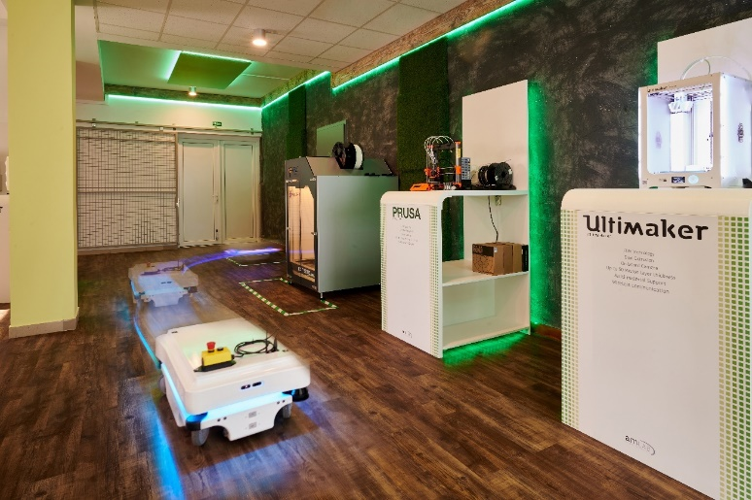
Figure 1: MIR 100 autonomous robot in operation at am-LAB

Simulation:

- Complex manufacturing simulation and training in am-LAB Digital Innovation HUB with special teaching and learning factory unit

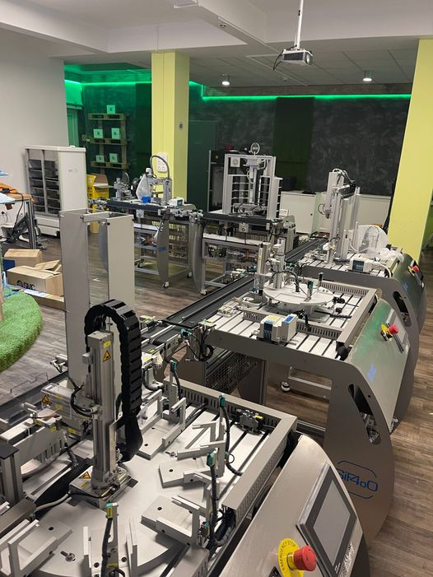
Figure 2: The Teaching and Learning Factory at am-LAB (PBN’s DIH) premises since 30th Nov 2021

Additive manufacturing

- The related technologies and developments are being constantly monitored and followed by PBN (am-LAB) technical staff. The goal is the integration of the additive manufacturing – based on wide spectrum of polymer printers and expertise - into the research and development, prototype production and into mass customized manufacturing.

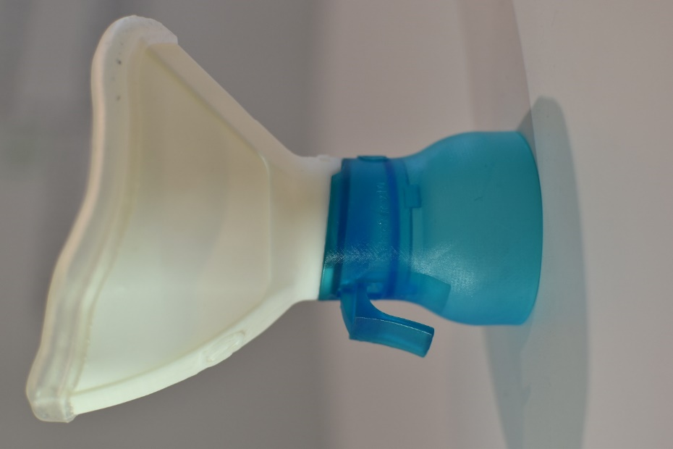
Figure 3: Prototype production using 3D printing (with FDM and SLA technologies)
Augmented Reality:

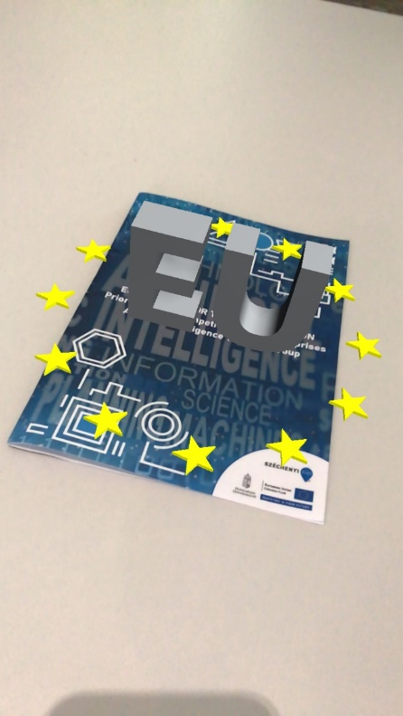
- We are focusing on industrial and marketing solutions with different AR technologies
Figure 4. Marketing brochure equipped with AR solution to make it more attractive
Big data analytics:

- Increasing the profitability and efficiency of businesses by analysing previously untapped but valuable data. Our service enables smaller businesses to profit from data analytical services.

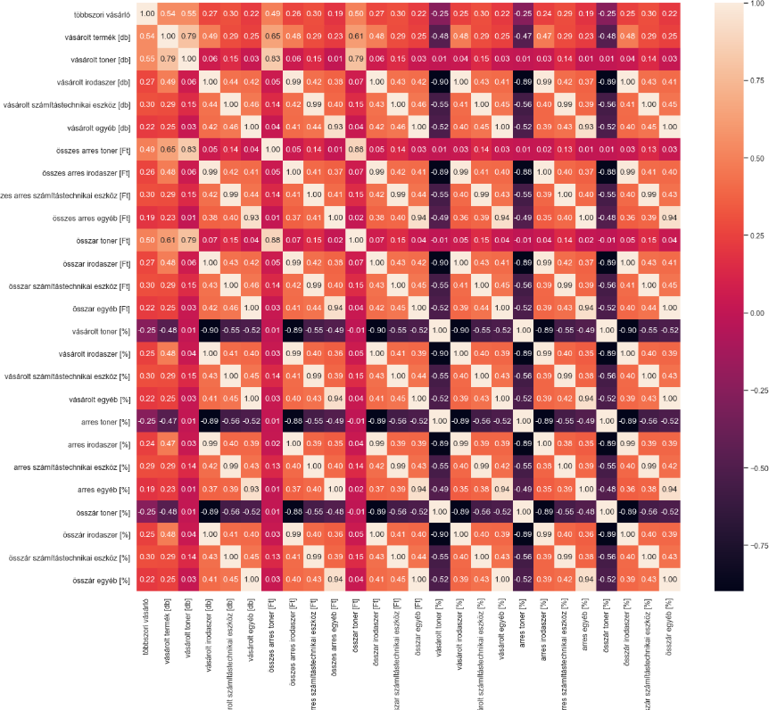
Figure 5: Heat map used in a web-shop advanced data analysis exercise

Smart Senior Room services

Regarding the newly (end of 2021) established and developed smart senior room ( called at.home) we can provide the following services:

- Attitude formulation (awareness raising) for:

- Seniors, relatives, caregivers,
- Institutions (e.g SMEs)
- Trainings:

- Accredited trainings
- Professional trainings
- Practical training place

- Research and Development:

- Prototype development
- Product development
- Innovative ideas
- Test facility:
- Households
- Data collection
- Data analysis showcase how to create value from data from digitalisation for companies including SMEs

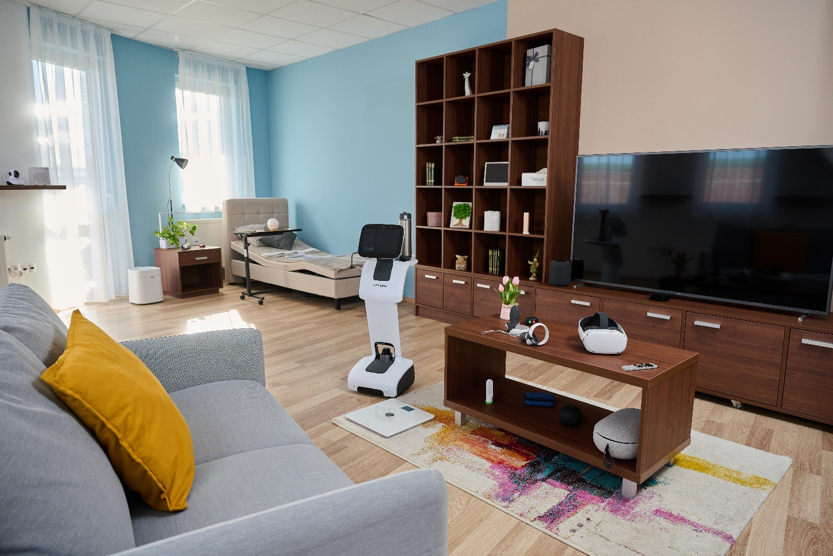
Figure 6: Smart senior room implemented at PBN /am-LAB premises

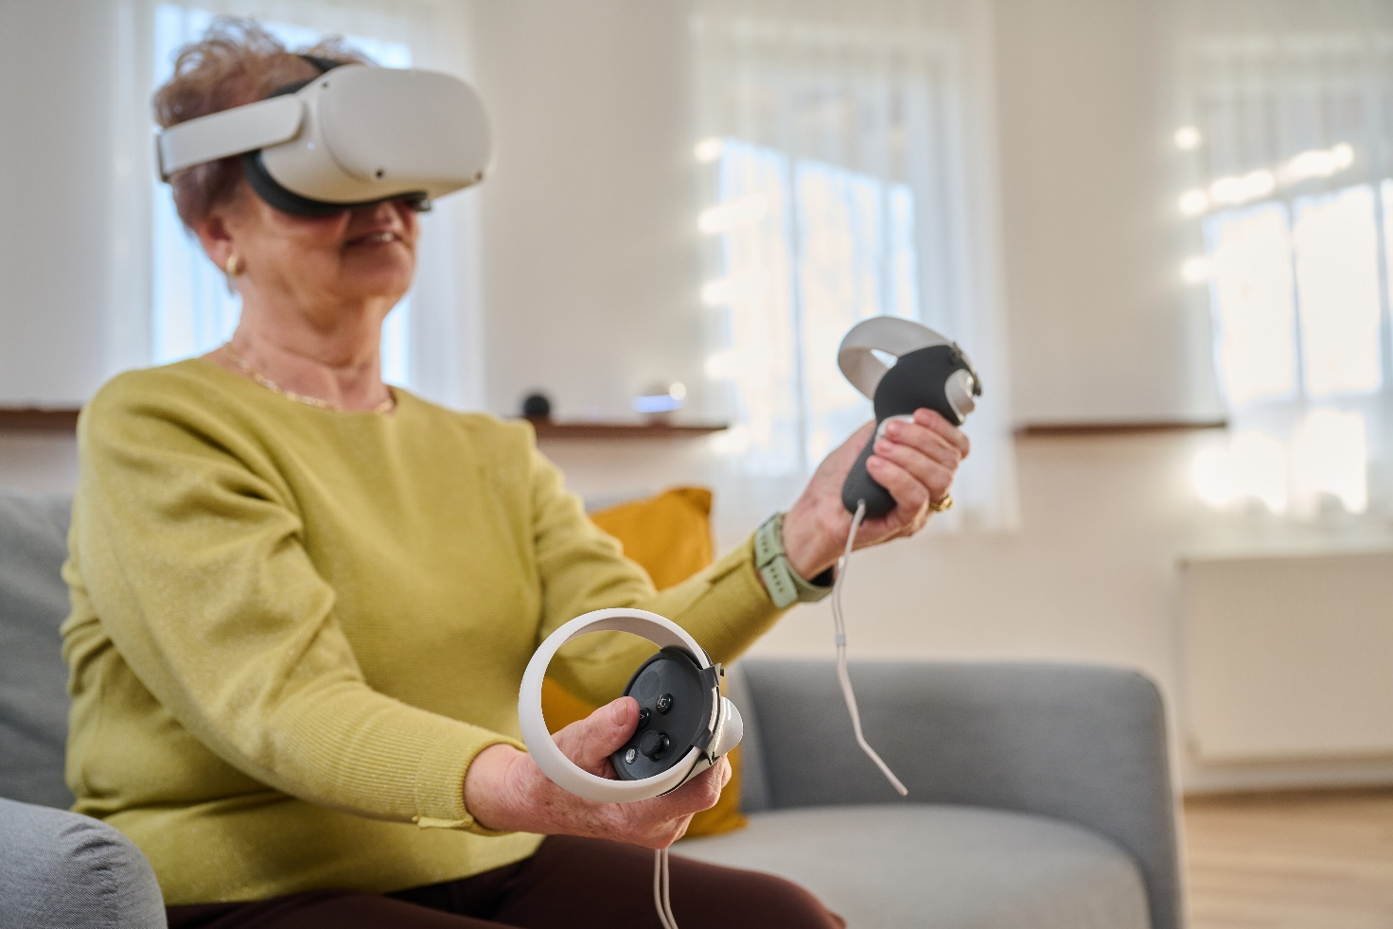
Figure 7: Senior lady is using some items in the smart senior room

