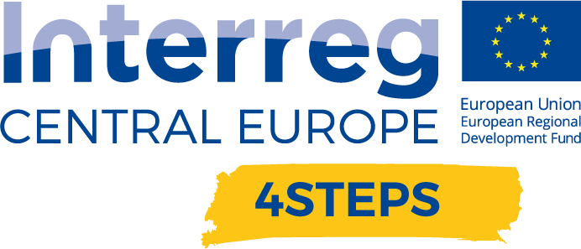
D.C. 5.3 Local focus groups events year 3

D.C.5.3 Report – Local focus groups events year 3 – Partner PP07 CCIS | Version 1  02 2022

- Name of the event, implementing date and place

Intronika 2022
16. 2. 2022, gospodarsko razstavišče, Ljubljana, Slovenia

- Number and types of participants/target groups
Intronika is a B2B trade fair for industrial and professional electronics. It is the answer to the growing needs of the companies and the pressure of the globalization process in Slovenia and the world in general. The wide range of INTRONIKA, together with the convenient location of the Ljubljana Exhibition and Convention Center, gives companies many opportunities to add value to their business. The visitors of the trade fair were representatives of DIH’s established in Slovenia, development centres, SMEs.
The total number of representatives at the event is difficult to assess, however 21 participants that stopped at our booth signed the attendance list.

- Topics tackled and links to deliverables, outputs
The event was mainly connected to the deliverable D.C.5.1 - Local focus groups events year 1 - sensitisation and collaboration with the local and D.C.5.2. Local focus groups events year 2 - focused on guidelines for TAP local implementation.

The main focus of this deliverable was on presenting and discussing the pilot intervention with local stakeholders in a public event. The adoption of project results was promoted.

- Expected effects and follow up
The expected effects of this event are:

- Gaining new business contacts
- Fostering existing business relationships
- Acknowledging and spreading project’s 4STEPS results

- Annexes: e.g. agenda of the event, pictures, media coverage web- links etc

