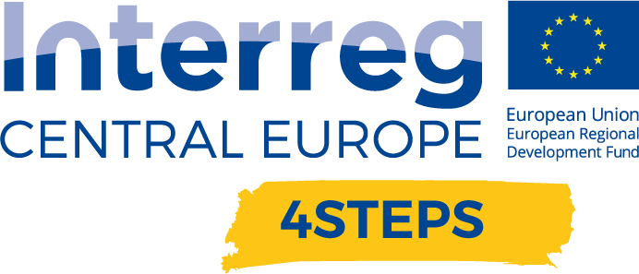
D.C. 5.2 Local focus groups events year 2

D.C. 5.2 Report – Local focus groups events year 2 – Partner CNA Emilia Romagna | Version 1  03 2021

- Name of the event, implementing date and place

NAME OF THE EVENT | DATE | PLACE
Future of Work:  nuovi modelli organizzativi e stili di leadership nel contesto aziendale post-emergenza | 10/06/2020 | webinar

- Number and types of participants/target groups
NAME OF THE EVENT | NUMBER OF PARTICIPANTS | TYPES OF PARTICIPANTS
Future of Work: new organization models and leadership styles in a post-emergency corporate context | 81 | SMEs+ DIH representatives of CNA in Emilia Romagna

- Topics tackled and links to deliverables, outputs

Future of Work: new organization models and leadership styles in a post-emergency corporate context (10/06/2020)
This workshop aimed at promoting a drive within SMEs towards a new business culture, in order to bring them to rethink a new organization and management model (both in management and leadership), and review new strategies and models of innovative business to be integrated in their companies, in an active and propositional way, avoiding to adapt passively to the technology advances imposed by work.
This topic, made very actual by the global emergency, which has caused a “forced innovation”, led the entrepreneurs and SMEs to quickly advance in a process of work transformation. The Future of Work is a wave able to overwhelm the different aspects of companies, leading them to necessarily rethink a new business culture, to define new innovative processes, to identify new organization and management models (both in management and leadership), and new strategies and models of innovative business.
This workshop was held by Professor Carlo Odoardi, in video-conference mode, owing to the COVID 19 emergency which stopped all physical movements of people, and it obtained a large participation from entrepreneurs, as the developed topic was very interesting in the present situation induced by Covid 19, in which companies have had to review their processes, behaviors, habits and expectations, starting anew from their work models and strategies.
In the full of the digital transformation era, the traditional work models are showing to be scarcely agile and adaptable. Men already work, and will increasingly operate in the future, in Man/Machine integrated systems (intelligent process automation, robots, etc.) and at the same time in a “digital team” modality (smart worker) and “in-person business team”. This will necessarily lead to design new innovative futures in a frame of Smart Organization System.
During this workshop, Professor Carlo Odoardi presented some models to rethink the modalities with which work is carried out: from a technological, cultural, organizational, managerial and leadership point of view, through concrete cases and tools of measurement, analysis and application in working contexts implemented with the Observatory for Organizational Innovation and Integrated Technology.

- Expected effects and follow up
The webinar, held by Prof. Carlo Odoardi in video conference mode, owing to the COVID 19 emergency, which blocked all physical movements of people, attracted a lot of interest from entrepreneurs given the current situation induced by Covid-19.
The companies have had to review their processes, starting from work models and strategies, relocating work environments, which are often replaced by virtual spaces and 'digital places'.
Prof. Carlo Odoardi presented some models of working methods, both from the technological, organizational, cultural and leadership point of view, in which it is emerging a new way of working and the effect of an inevitable change in relationships among people.
The SMEs of Emilia Romagna responded positively with respect to a widespread interest linked to Industry 4.0 and a generalized willingness to consider introducing investments in digital technologies into the company as necessary, as strategic elements for the competitiveness of the company in the next years. Following this webinar, various expressions of interest were collected from companies to investigate the issue of digital efficiency and to continue organizing seminars on the Industry 4.0 focus.

- Annexes: e.g. agenda of the event, pictures, media coverage web- links etc

NAME OF THE EVENT | LINK
Future of Work: new organization models and leadership styles in a post-emergency corporate context | https://www.interreg-central.eu/Content.Node/4STEPS/Future-of-Work-new-organizational-models-and-leadership-sty.html

